**Unit 7 : Right TriangleTrigonometry**

Math II

Spring 2018

**Day 1 – Pythagorean Theorem**

c

a

**Pythagorean Theorem: __________________________**

b

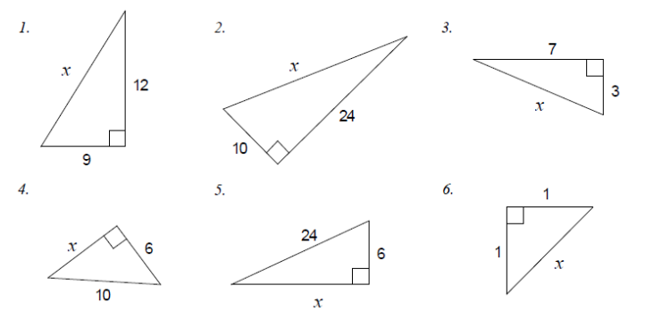Solve for the missing side by using pythagorean theorem.



**Applications to Pythagorean Theorem**

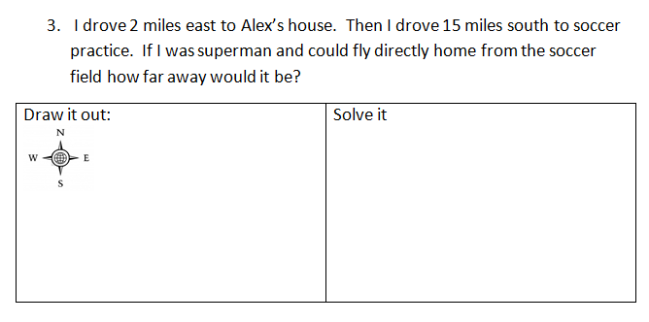

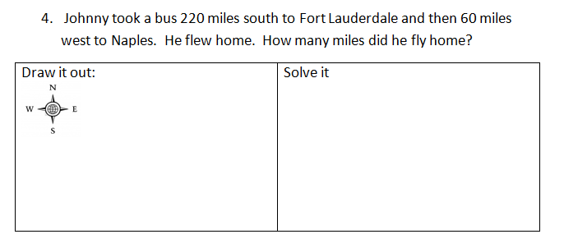

5.The bottom of a 13-foot straight ladder is set into the ground 5 feet away from a wall. When the top of the ladder is leaned against the wall, what is the distance above the ground it will reach?

6. In shop class, you make a table.  The sides of the table measure 36" and 18".  If the diagonal of the table measures 43", is the table “square”?  (In construction, the term "square” just means the table has *right angles* at the corners.)

7. A 38 ft. ladder is leaning against a wall. It’s base is 26 ft from the wall. How high above ground is the ladder?

8. A ladder is leaning against a wall. It’s base is 31 ft from the wall and the ladder is reaching a point 26 ft above ground. What is the length of the ladder?

9. The slide at the playground has a height of 6 feet. The base of the slide measured on the ground is 8 feet. What is the length of the sliding board?

10.The bottom of a 13-foot straight ladder is set into the ground 5 feet away from a wall. When the top of the ladder is leaned against the wall, what is the distance above the ground it will reach?

**Pythagorean Theorem and its converse**

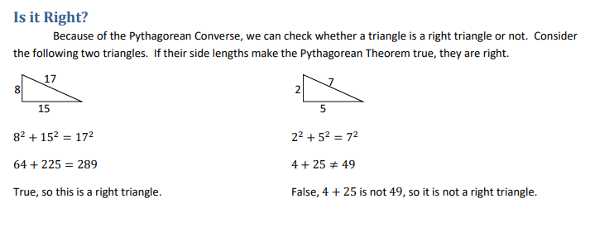

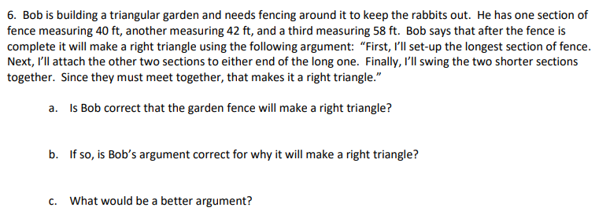

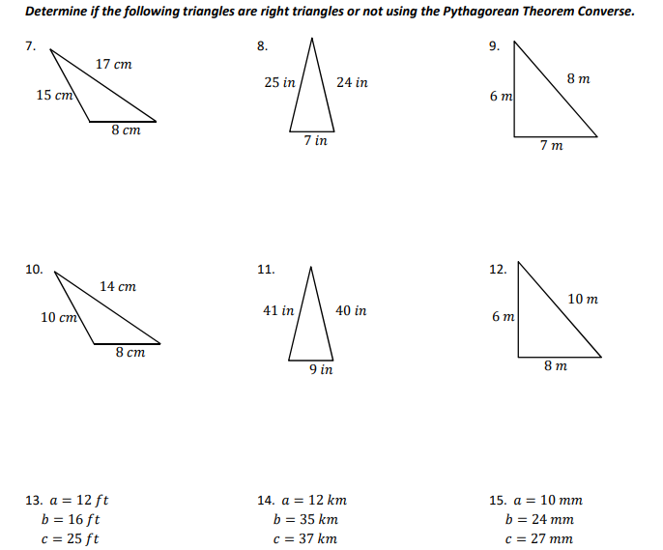

**Day 1 Homework:**

How To check if a triangle is acute or obtuse using Pythagorean Theorem:

1. If **a2 + b2 > c2**, then lengths a, b, and c make up an **acute triangle**.
2. If **a2 + b2** < **c2** , then lengths a, b , and c make up the sides of an **obtuse triangle**.

**It is important to note that the length ‘‘c′′ is always the longest**.

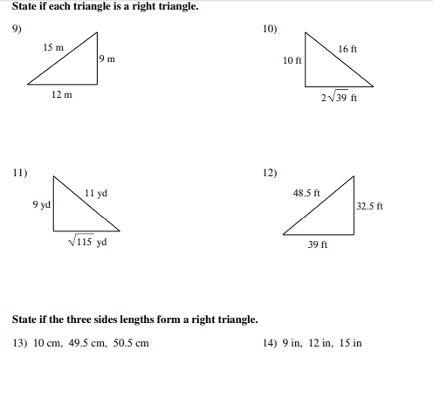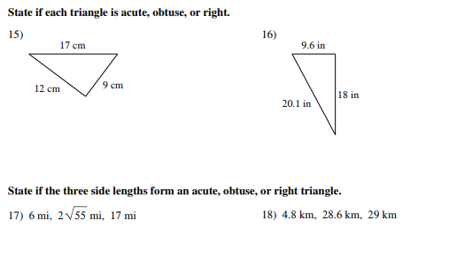

**Day 2: Special Right Triangles**

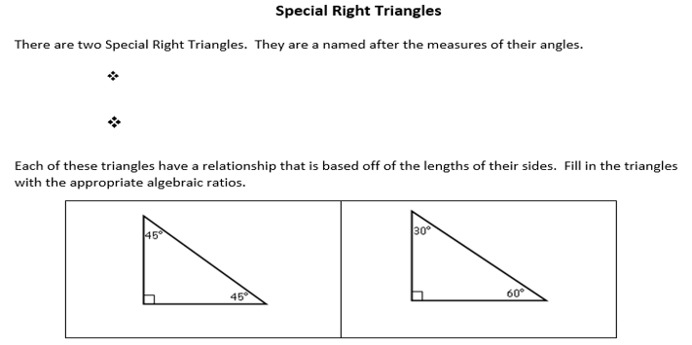

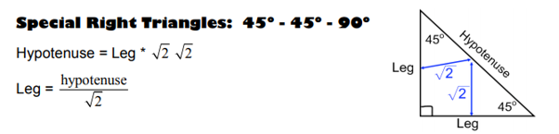

Consider a square with a diagonal drawn. Given a sides find the diagonal of the square.

45°

If the side was 4, then If the side was 7, then

 

45°

If the side was 10, then Do you see the pattern? 

If the side was 13, then

If the side was ½ , then

If the side was , then

So if given a leg of a 45°-45°-90° triangle, you only need to multiply the leg by 

What if we want to work the other way? What if we are given the hypotenuse? **Well, if we multiply to go from leg to hypotenuse, when we want to go from hypotenuse to leg we should divide.** (the inverse operation)

So, if the hypotenuse is 4, then the leg is . However, it is not “proper” to leave a square root on the bottom, so we rationalize the fraction.

 So the leg is .

If the hypotenuse is 6, then the leg is.

If the hypotenuse is 10, then the leg is.

If the hypotenuse is 7, then the leg is.

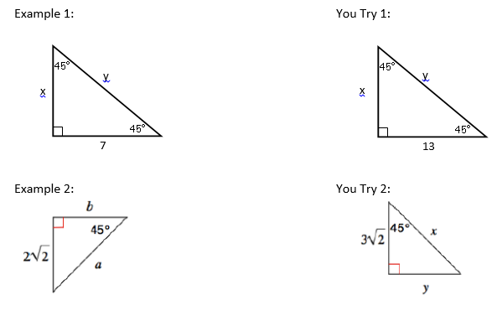

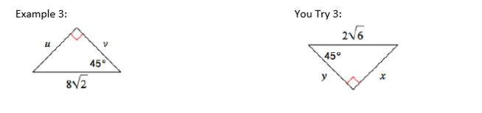

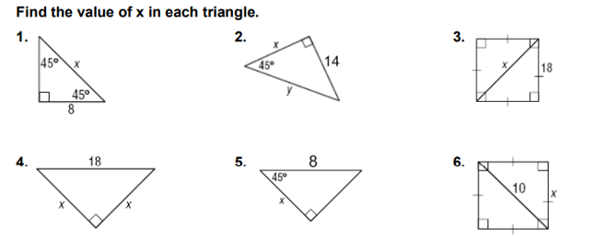

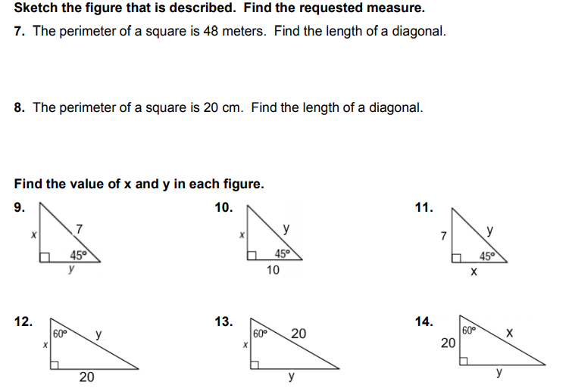

**Day 2 Homework**:

**Solve for the missing sides in each of the given triangles using the relationships for special right triangles. Leave all answers as simplified radicals.**



*x*

*y*

*15*

*45°*



$$12\sqrt{2}$$

*45°*

*y*

*x*



*x*

$$4\sqrt{2}$$

*y*

**x = ____________**

**y = ____________**

**x = ____________**

**y = ____________**

**x = ____________**

**y = ____________**

x

y

18

45°



$$12\sqrt{6}$$

*45°*

*y*

*x*

**6)**

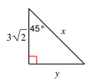

**x = ____________**

**y = ____________**

**x = ____________**

**y = ____________**

**x = ____________**

**y = ____________**

**Day 3: Special Right Triangle Continues**

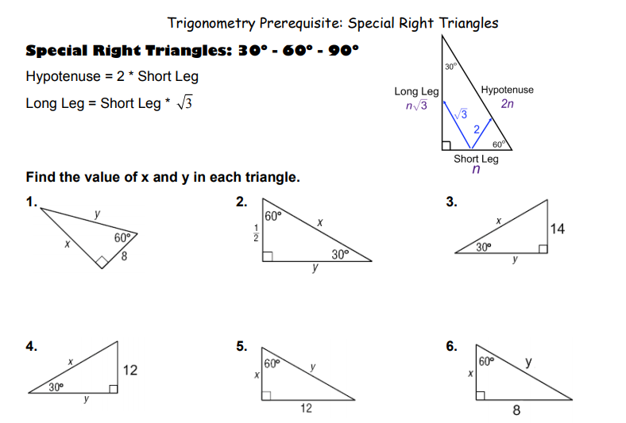

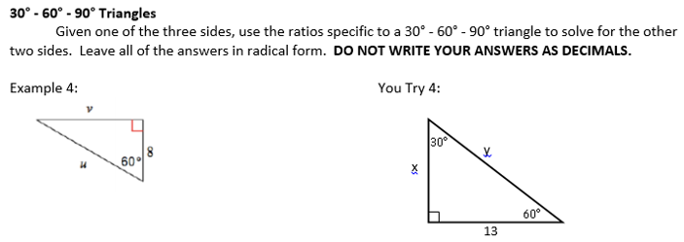

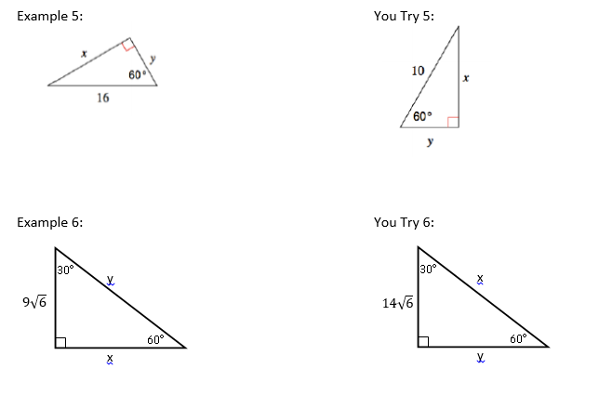

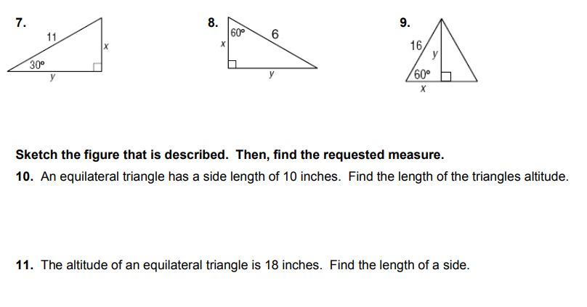

**Special Right Triangles Practice**

Login to: <https://tinyurl.com/specialtrianglepractice> and complete the problems on your own paper

**Day 3 Classwork:**

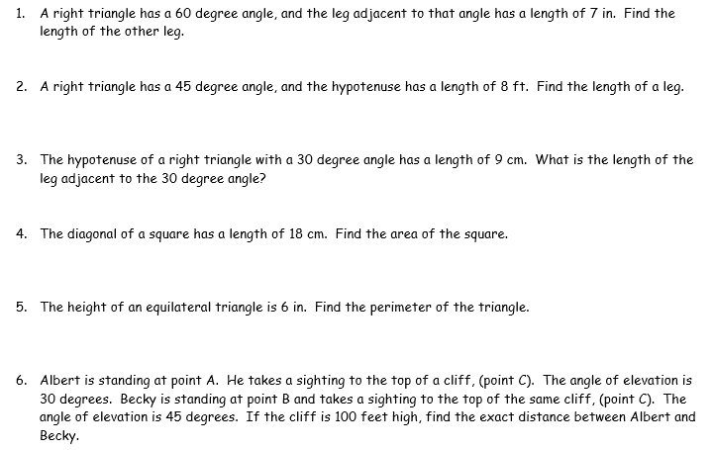

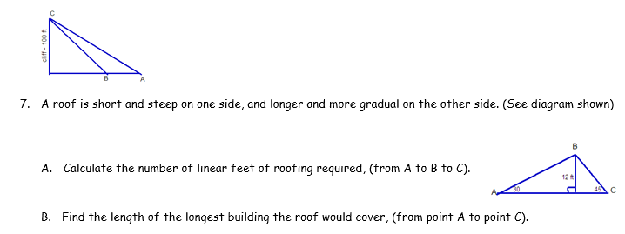

**Solve for the missing sides in each of the given triangles using the relationships for special right triangles. Leave all answers as simplified radicals.**

|  |  |  |
| --- | --- | --- |
| *26*  *y*  *60°*  *x*  **x = ____________**  **y = ____________**  *60°*  *x*  *y*  *28* | *30°*  *x*  *y*    **x = ____________**  **y = ____________** | *60°*  *x*  *y*    **x = ____________**  **y = ____________** |
| *60°*  *x*  *y*  *28*  *60°*  *x*  *y*  *28*  **x = ____________**  **y = ____________** | y  x  **x = ____________**  **y = ____________** | **x = ____________**  **y = ____________** |

**Day 3 Homework:**

**Solve for the missing sides in each of the given triangles using the relationships for special right triangles. Leave all answers as simplified radicals.**



**

*45°*

*x*

*y*

*x*

*30°*

$$12\sqrt{6}$$

*y*



**

*45°*

*x*

*y*

**x = ____________**

**y = ____________**

**x = ____________**

**y = ____________**

**x = ____________**

**y = ____________**

1. In a 30°- 60°- 90°triangle, the shorter leg is 6ft long. Find the length of the other two legs.

Longer Leg = __________

Hypotenuse = __________



6

1. The hypotenuse of an isosceles right triangle is 10 inches. Find the length of the isosceles right triangle.

Length of the Side = __________

1. The perimeter of a square is 32 fee. Find the length of one of the diagonals.

Length of the diagonal = __________

1. An altitude of an equilateral triangle is $10\sqrt{3}$ units. What is the perimeter of the equilateral triangle?

Perimeter = __________

1. Find the length of the diagonal of a square that has sides of length 30cm.

Side Length = __________

**Day 4: Soh Cah Toa (solving for missing side)**

**What is trigonometry?**

* Trigonometry is the study of _________________________________________.
* We will use ______________, _________________ and _________________ ratios to find missing sides and angles.

$sin∠=\frac{opposite}{hypotenuse}$ $cos∠=\frac{adjacent}{hypotenuse}$ $tan∠=\frac{opposite}{adjacent}$

**Soh Cah Toa**

Soh Cah Toa will help you remember how to set up your trig ratios.

**Steps for Solving for missing measurements using trig**

1. Label the given sides as either *opposite, adjacent, or hypotenuse*

______________ is opposite of the right angle.

______________ is opposite of the *given* angle.

______________ is the **leg** that is **beside** the given angle (but not the hypotenuse!)

2. Use Soh Cah Toa to set up the ratio.

3. Solve for the missing measurement.

**Label the sides as opposite (O), adjacent (a), or hypotenuse (h). The placement of opp and adj is based off of the given angle (never the right angle)**

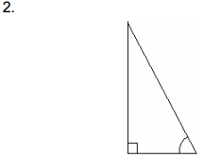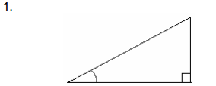

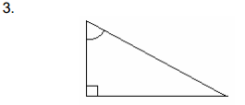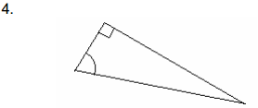

**You try!**

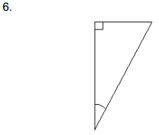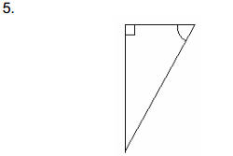

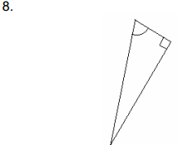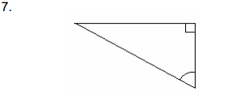

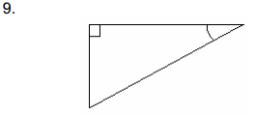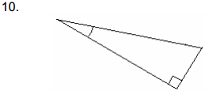

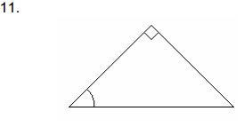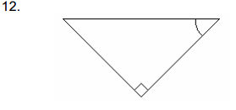

**Solve for x.**

Notice that the angle is in degrees. Because of this, you MUST to put your calculator in DEGREE MODE!!!

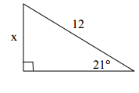

**Example #1**

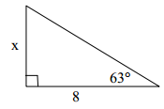**Example #2**

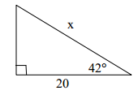**Example #3**

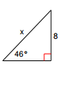**You try!**

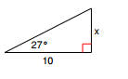**#4 #5**

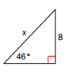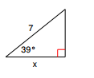**#6 #7**

**Practice: solve for x**

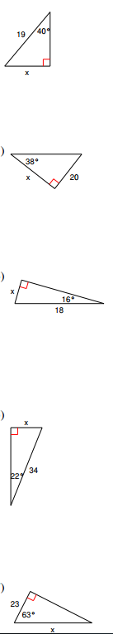1. 2. 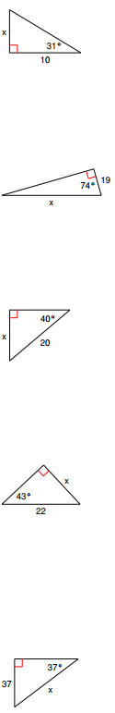

3. 4.

5. 6.

7. 8.

9. 10.

**Day 4 Homework:**

Solve for x

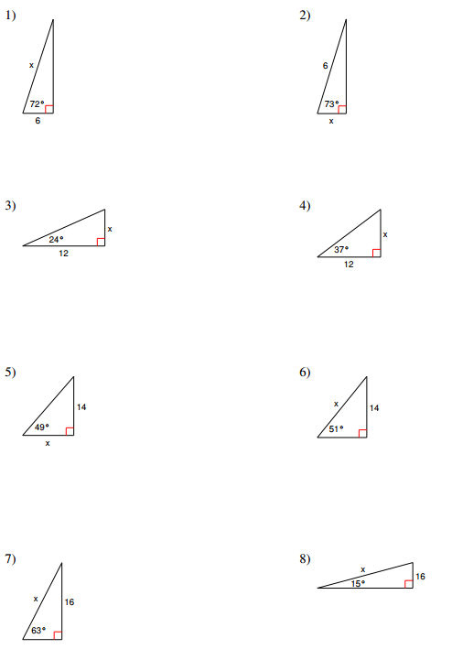

**Day 5: Soh Cah Toa (solving for missing angle)**

Warm-Up

Solve for x.

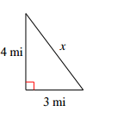1. 2.

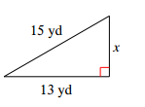

3. 4.

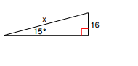 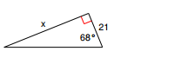

5. You're locked out of your house and the only open window is on the second floor, 25 feet above the ground. You need to borrow a ladder from one of your neighbors. There's a bush along the edge of the house, so you'll have to place the ladder 10 feet from the house. What length of ladder do you need to reach the window?

**Using Trig to solve for a missing angle**

**Example #1 Example #2**

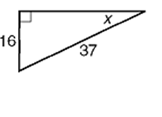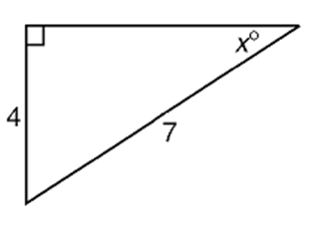

**Example #3 You Try!**

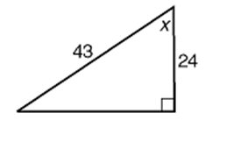

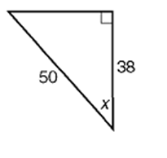

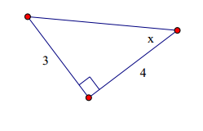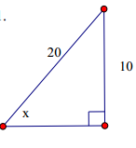**4. 5.**

Practice: find the missing angle

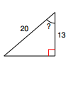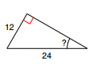

1. 2.

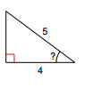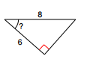

3. 4.

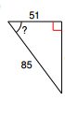

5. 6.

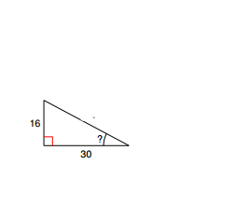



7. 8.

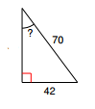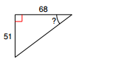

9. 10.

**Day 5 Homework:**

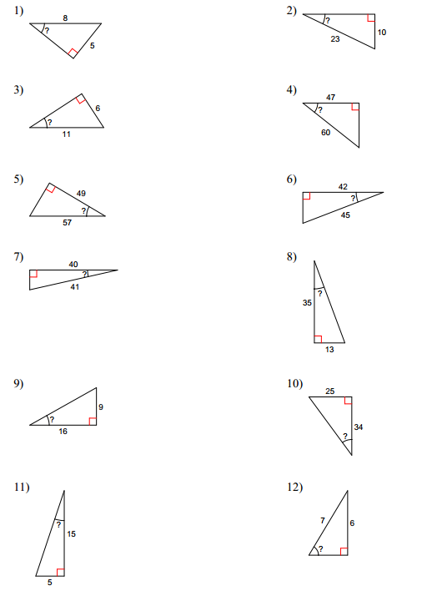

**Day 6 – Soh Cah Toa (all)**

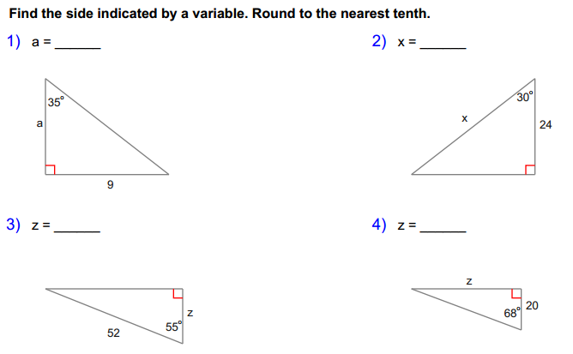



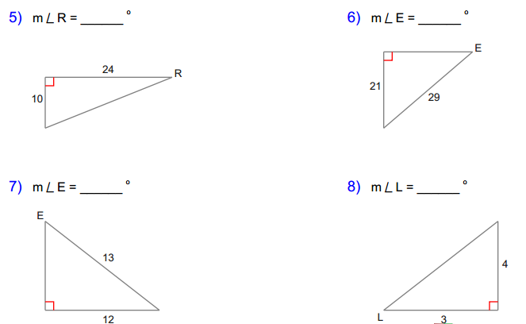

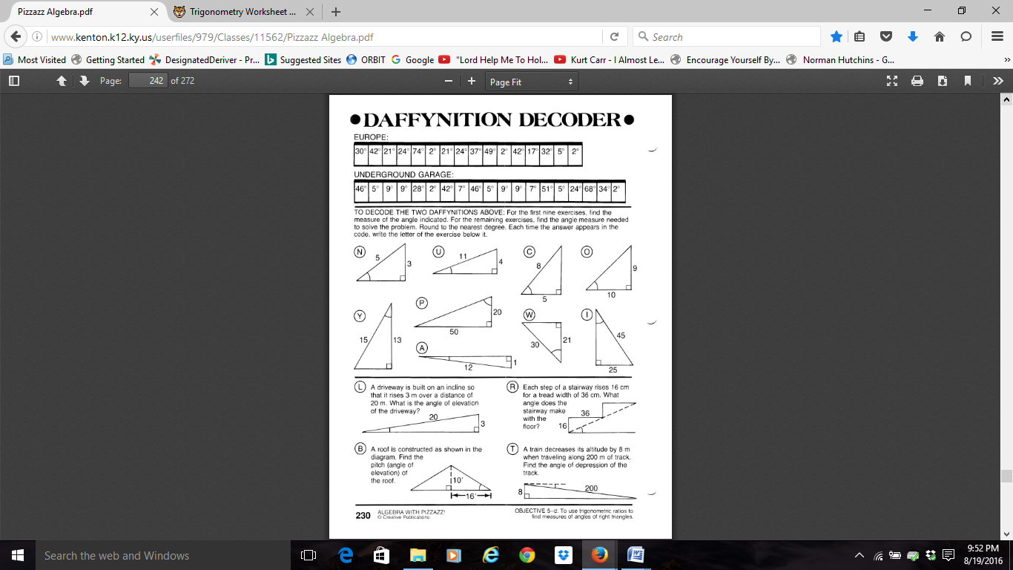

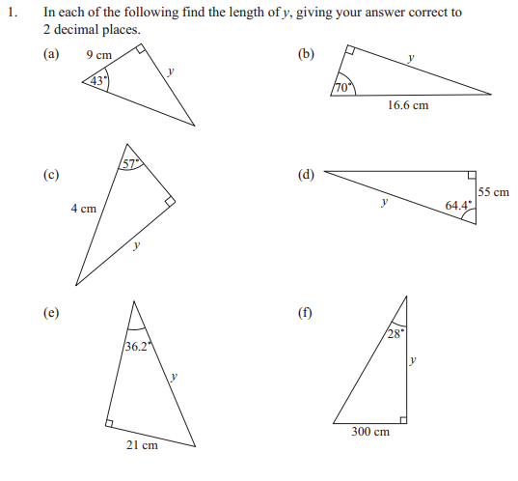

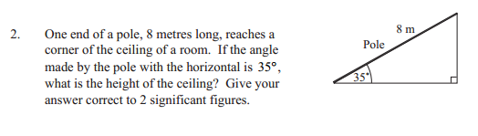

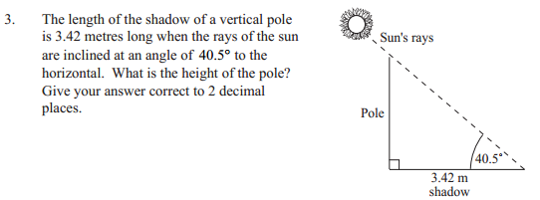

**Day 6 Homework:**

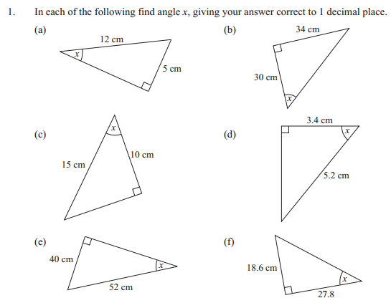

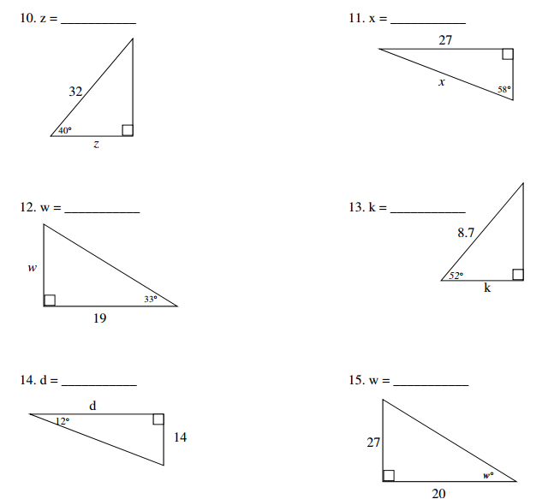

3.

2.

7.

6.

5.

4.

**Day 7: Trig Applications**

**Angles of Elevation and Depression**

1. Angles of Elevation and Depression

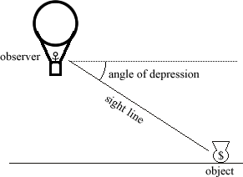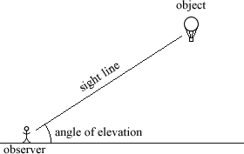

Notice … the angle of elevation and the angle of depression are _____________________________ when in the same picture!

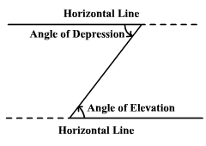

**Example #1** A 20-foot ladder leans against a wall so that the base of the ladder is 8 feet from the base of the building. What is the ladder’s angle of elevation?

**Example #2** A 50-meter vertical tower is braced with a cable secured at the top of the tower and tied 30 meters from the base. What is the angle of depression from the top of the tower to the point on the ground where the cable is tied?

**Example #3** At a point on the ground 50 feet from the foot of a tree, the angle of elevation to the top of the tree is 53°. Find the height of the tree.

**Example #4** From the top of a lighthouse 210 feet high, the angle of depression of a boat is 27°. Find the distance from the boat to the foot of the lighthouse. The lighthouse was built at sea level.

**Example #5** Richard is flying a kite. The kite string has an angle of elevation of 57°. If Richard is standing 100 feet from the point on the ground directly below the kite, find the length of the kite string.



**Example #6** An airplane rises vertically 1000 feet over a horizontal distance of 5280 feet. What is the angle of elevation of the airplane’s path?

**Example #7** A person at one end of a 230-foot bridge spots the river’s edge directly below the opposite end of the bridge and finds the angle of depression to be 57°. How far below the bridge is the river?

230

**You Try 1:** The angle of elevation from a car to a tower is 32°. The tower is 150 ft. tall. How far is the car from the tower?

**You Try 2:** A radio tower 200 ft. high casts a shadow 75 ft. long. What is the angle of elevation of the sun?

**You Try 3:** An escalator from the ground floor to the second floor of a department store is 110 ft long and rises 32 ft. vertically. What is the escalator’s angle of elevation?

**You Try 4:** Electronic instruments on a treasure-hunting ship detect a large object on the sea floor. The angle of depression is 29°, and the instruments indicate that the direct-line distance between the ship and the object is about 1400 ft. About how far below the surface of the water is the object, and how far must the ship travel to be directly over it?

1400

**You Try 5:** A ladder on a fire truck has its base 8 ft. above the ground. The maximum length of the ladder is 100 ft. If the ladder’s greatest angle of elevation possible is 70°, what is the highest above the ground that it can reach?

8

100

**Day 7 Homework:**

1. Brian’s kite is flying above a field at the end of 65 m of string. If the angle of elevation to the kite measures 70°, how high is the kite above Brian’s head?
2. A great white shark swims 22 feet below sea level. If the shark is 67.7 feet from the sailboat, what is the angle of depression of the boat to the shark?
3. If a 50 foot cable supporting a circus tent is staked into the ground at an angle of elevation of 37o, how far from the tent must the stake be placed?
4. A bird is flying at a height of 40 feet and spots an 8 ft ledge on which to perch. If the top of the ledge is at a 22o angle of depression from the bird, how far must the bird fly before it can land?
5. From an airplane at an altitude of 1200 m, the angle of depression to a rock on the ground measures 28°. Find the distance from the plane to the rock.
6. A kite with a string 150 feet long makes an angle of 45o with the ground. How high is the kite?
7. A tree 10 meters high casts a 17.3 meter shadow. Find the angle of elevation of the sun.

**Day 8 – Soh Cah Toa Applications cont.**

1. A man flies a kite with a 100 foot string. The angle of elevation of the string is 52 o . How high off the ground is the kite?

2. From the top of a vertical cliff 40 m high, the angle of depression of an object that is level with the base of the cliff is 34º.  How far is the object from the base of the cliff?

3. An airplane takes off 200 yards in front of a 60 foot building. At what angle of elevation must the plane take off in order to avoid crashing into the building? Assume that the airplane flies in a straight line and the angle of elevation remains constant until the airplane flies over the building.

4. A 14 foot ladder is used to scale a 13 foot wall. At what angle of elevation must the ladder be situated in order to reach the top of the wall?

5. A person stands at the window of a building so that his eyes are 12.6 m above the level ground. An object is on the ground 58.5 m away from the building on a line directly beneath the person. Compute the angle of depression of the person’s line of sight to the object on the ground.

6. A ramp is needed to allow vehicles to climb a 2 foot wall. The angle of elevation in order for the vehicles to safely go up must be 30 o or less, and the longest ramp available is 5 feet long. Can this ramp be used safely?

7. Taylor is looking out of a window. Her eyes are 900 feet above ground. She sees a car outside the window that is 1550 feet from her. **Approximately** how far is the car from the entrance to the building?

8. The bottom of a ladder must be placed 3 feet from a wall. The ladder is 12 feet long. How far above the ground

does the ladder touch the wall?

9. How far from the base of the house do you need to place a 15-foot ladder so that it exactly reaches the top of a

12-foot tall wall?

10. John leaves school to go home. He walks 6 blocks North and then 8 blocks west. How far is John from the school?

11. In a computer catalog, a computer monitor is listed as being 19 inches. This distance is the diagonal distance across the screen. If the screen measures 10 inches in height, what is the actual width of the screen to the nearest inch?

12. The slide at the playground has a height of 6 feet. The base of the slide measured on the ground is 8 feet. What is the length of the sliding board?

13.The bottom of a 13-foot straight ladder is set into the ground 5 feet away from a wall. When the top of the ladder is leaned against the wall, what is the distance above the ground it will reach?

14. In shop class, you make a table.  The sides of the table measure 36" and 18".  If the diagonal of the table measures 43", is the table “square”?  (In construction, the term "square” just means the table has *right angles* at the corners.)

**Day 8 Homework:**

1. A plane is flying at an altitude of 12,000 m. From the pilot, the angle of depression to the airport tower is 32o. How far is the tower from a point directly beneath the plane?

2. A car is traveling up a slight grade with an angle of elevation of 2o. After traveling 1 mile, what is the vertical change in feet? (1 mile = 5280 feet)

3. From the top of a fence, a person sees a lion on the ground at an angle of depression of 24o. If the man and the fence is 4.2 meters high, how far is the man from the lion?

4. A 300 meter cable is attached to the top of an antenna. The angle of elevation to the top of the antenna is 15o. How high is the antenna?

5. The angle of elevation from a boat to the top of a 90 meter hotel is 10o. How far is the boat from the base of the hotel?

6. A person is standing 30 meters from a traffic light. If the angle of elevation from the person’s feet to the top of the traffic light is 25o, find the height of the traffic light.

7. A 12 meter ladder is inclined against a brick wall at an angle of 15o. If the top of the ladder reaches the top of the wall, how tall is the wall?

8. From a point on the ground 12 ft from the base of a flagpole, the angle of elevation of the top of the pole measures 53°. How tall is the flagpole?

**Unit 7: Trigonometry**

**Day 9: Study Guide**

1. **Find the missing sides using Pythagorean Theorem.**

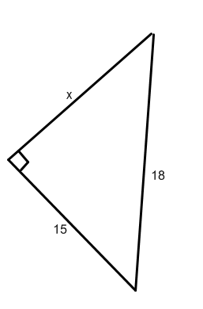

1. 2. 3. 8 10

x

x

14

14

1. **Use the Pythagorean Theorem Converse to tell whether each set of numbers would form an acute, obtuse, or right triangle.**

1. 4.6, 8.7, 9.9

1. 35, 21, 28
2. 26, 20, 18
3. 27, 45, 36
4. **Find the values of the missing sides using the rules for Special Right Triangles. Answers should be kept as radicals and not as decimals.**

2.

y

1.

y

22

60°

x

50

30°

x

19 $\sqrt{15}$

3.

30°

y

4.

x

13

45°

y

1. 6.

y

x

45°

$$13\sqrt{2}$$

x

$$39\sqrt{2}$$

45°

y

1. **Find the missing sides and/or angles using SOH CAH TOA.**

1. 2.

8

x

10

x

67o 14

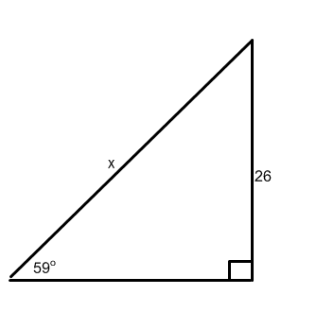

4.

3.

x

30

18o

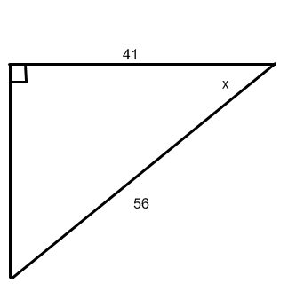 5.

6. 7.

8

x

10 x

67o 14

8.

x



18o

**IV. Trig applications. Solve each of the following using Pythagorean Theorem or SOH CAH TOA**

1. John is looking out of a window. His eyes are 82 feet above ground, and he sees an object outside that is 115 feet from him. How far is the object from the base of the building?

2. Jay flies a kite. The angle of elevation is 26o and he has let all 200 ft of string out. How far above the ground is the kite? Assume Jay is laying on the ground.

3. A 42 foot ladder is leaning against a building. If the angle of elevation is 18o, how far is the foot of the ladder from the base of the building?

4. The angle of elevation to the top of the Empire State Building in New York is  from a point on the ground 1 mile from

the base of the building. Find the height of the Empire State Building in feet.

5. A 96 foot tree casts a shadow that is 120 feet long. What is the angle of elevation of the sun?

6. A man is lying on the beach, flying a kite. He holds the end of the kite string at ground level and estimates the angle of

elevation of the kite to be . If the string is 450 feet long, how high is the kite above the ground?

7. A builder wishes to construct a ramp 24 feet long that rises to a height of 5 feet above the ground. Find the angle of

elevation of the ramp.

8. The angle of elevation to the top of the Empire State Building in New York is  from a point on the ground 1 mile (5280 ft) from the base of the building. Find the height of the Empire State Building in feet.

9. A new TV has a 55” diagonal. If it is 40” wide, how tall is the TV in inches?

10. A 96 foot tree casts a shadow that is 120 feet long. What is the angle of elevation of the sun?