**Unit 5: Parallel lines, Angles and Properties of Triangles**

**Math 2**

**Spring 2018**

# State standards

**NC.M2.G-CO.9: Prove theorems about lines and angles and use them to prove relationships in geometric figures including:**

* **Vertical angles are congruent.**
* **When a transversal crosses parallel lines, alternate interior angles are congruent.**
* **When a transversal crosses parallel lines, corresponding angles are congruent.**
* **Points are on a perpendicular bisector of a line segment if and only if they are equidistant from the endpoints of the segment.**
* **Use congruent triangles to justify why the bisector of an angle is equidistant from the sides of the angle.**

**NC.M2.G-CO.10: Prove theorems about triangles and use them to prove relationships in geometric figures including:**

* **The sum of the measures of the interior angles of a triangle is 180º.**
* **An exterior angle of a triangle is equal to the sum of its remote interior angles.**
* **The base angles of an isosceles triangle are congruent.**
* **The segment joining the midpoints of two sides of a triangle is parallel to the third side and half the length.**

**NC.M2.G-SRT.2: Understand similarity in terms of transformations.**

1. **Determine whether two figures are similar by specifying a sequence of transformations that will transform one figure into the other.**
2. **Use the properties of dilations to show that two triangles are similar when all corresponding pairs of sides are proportional and all corresponding pairs of angles are congruent.**

**NC.M2.G-SRT.3: Use transformations (rigid motions and dilations) to justify the AA criterion for triangle similarity.  
  
NC.M2.G-SRT.4: Use similarity to solve problems and to prove theorems about triangles. Use theorems about triangles to prove relationships in geometric figures.**

* **A line parallel to one side of a triangle divides the other two sides proportionally and its converse.**

**The Pythagorean Theorem**

**NC.M2.G-SRT.2: Understand similarity in terms of transformations.**

1. **Determine whether two figures are similar by specifying a sequence of transformations that will transform one figure into the other.**
2. **Use the properties of dilations to show that two triangles are similar when all corresponding pairs of sides are proportional and all corresponding pairs of angles are congruent.**

**NC.M2.G-SRT.3: Use transformations (rigid motions and dilations) to justify the AA criterion for triangle similarity.  
  
NC.M2.G-SRT.4: Use similarity to solve problems and to prove theorems about triangles. Use theorems about triangles to prove relationships in geometric figures.**

* **A line parallel to one side of a triangle divides the other two sides proportionally and its converse.**

**The Pythagorean Theorem**

**NC.M2.G-CO.10: Prove theorems about triangles and use them to prove relationships in geometric figures including**

* **The base angles of an isosceles triangle are congruent.**
* **The segment joining the midpoints of two sides of a triangle is parallel to the third side and half the length.**

# **Day 1: Lines & Angles**

**Linear Pair Angles** – Angles that are \_\_\_\_\_\_\_\_\_\_\_\_\_\_\_\_\_\_\_\_\_\_ and form a straight line. (i.e. ∠\_\_\_ and ∠\_\_\_

(next to each other) or ∠\_\_\_ and ∠\_\_\_ )

\*\* Linear Pairs are \_\_\_\_\_\_\_\_\_\_\_\_\_\_\_\_\_\_\_\_\_\_\_\_\_\_\_\_\_\_\_\_\_\_\_\_\_\_\_\_\_\_\_\_

(Adds up to equal 180°)

**Vertical Angles** – Two \_\_\_\_\_\_\_\_\_\_\_\_\_\_\_\_\_\_\_\_\_\_\_\_\_\_\_\_\_\_\_\_ formed by a pair of intersecting lines. (i.e. ∠\_\_\_ and ∠\_\_\_

(opposite) or ∠\_\_\_ and ∠\_\_\_ )

\*\*Vertical angles are \_\_\_\_\_\_\_\_\_\_\_\_\_\_\_\_\_\_\_\_\_\_\_\_\_\_\_\_\_.

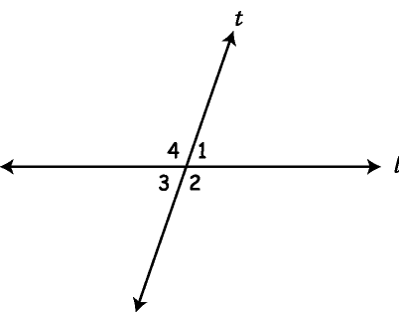 (has the same measures)

**Lines and Transversals**

* Parallel lines – T
* Transversal – m
* Exterior Angles–

n

* Interior Angles –
* Alternate side Angles –
* Same Side Angles –

### Types of Angle Pairs formed by parallel lines and a transversal

Corresponding Angles –

1

5\

2

6

3

7

4

8

l

m

t

\_\_\_\_\_\_\_\_\_\_\_\_\_\_\_\_\_\_\_\_\_\_\_\_\_\_\_\_\_\_\_\_\_\_\_\_\_\_\_\_\_\_\_\_\_\_\_\_\_\_\_\_\_\_\_\_\_\_\_\_\_\_\_\_\_

\_\_\_\_\_\_\_\_\_\_\_\_\_\_\_\_\_\_\_\_\_\_\_\_\_\_\_\_\_\_\_\_\_\_\_\_\_\_\_\_\_\_\_\_\_\_\_\_\_\_\_\_\_\_\_\_\_\_\_\_\_\_\_\_\_

Same-Side Interior Angles – aka (Consecutive Angles)

1

5\

2

6

3

7

4

8

l

m

t

\_\_\_\_\_\_\_\_\_\_\_\_\_\_\_\_\_\_\_\_\_\_\_\_\_\_\_\_\_\_\_\_\_\_\_\_\_\_\_\_\_\_\_\_\_\_\_\_\_\_\_\_\_\_\_\_\_\_\_\_\_\_\_\_

\_\_\_\_\_\_\_\_\_\_\_\_\_\_\_\_\_\_\_\_\_\_\_\_\_\_\_\_\_\_\_\_\_\_\_\_\_\_\_\_\_\_\_\_\_\_\_\_\_\_\_\_\_\_\_\_\_\_\_\_\_\_\_\_

Same-Side Exterior Angles – aka (Consecutive Angles)

\_\_\_\_\_\_\_\_\_\_\_\_\_\_\_\_\_\_\_\_\_\_\_\_\_\_\_\_\_\_\_\_\_\_\_\_\_\_\_\_\_\_\_\_\_\_\_\_\_\_\_\_\_\_\_\_\_\_\_\_\_\_\_

1

5\

2

6

3

7

4

8

l

m

t

\_\_\_\_\_\_\_\_\_\_\_\_\_\_\_\_\_\_\_\_\_\_\_\_\_\_\_\_\_\_\_\_\_\_\_\_\_\_\_\_\_\_\_\_\_\_\_\_\_\_\_\_\_\_\_\_\_\_\_\_\_\_\_

Alternate Interior Angles – \_\_\_\_\_\_\_\_\_\_\_\_\_\_\_\_\_\_\_\_\_\_\_\_\_\_\_\_\_\_\_\_\_\_\_\_\_\_\_\_\_\_\_\_\_\_\_\_\_\_\_\_\_\_\_\_\_\_\_\_\_\_\_\_

1

5\

2

6

3

7

4

8

l

m

t

\_\_\_\_\_\_\_\_\_\_\_\_\_\_\_\_\_\_\_\_\_\_\_\_\_\_\_\_\_\_\_\_\_\_\_\_\_\_\_\_\_\_\_\_\_\_\_\_\_\_\_\_\_\_\_\_\_\_\_\_\_\_\_\_

Alternate Exterior Angles – \_\_\_\_\_\_\_\_\_\_\_\_\_\_\_\_\_\_\_\_\_\_\_\_\_\_\_\_\_\_\_\_\_\_\_\_\_\_\_\_\_\_\_\_\_\_\_\_\_\_\_\_\_\_\_\_\_\_\_\_\_\_\_\_

1

5\

2

6

3

7

4

8

l

m

t

\_\_\_\_\_\_\_\_\_\_\_\_\_\_\_\_\_\_\_\_\_\_\_\_\_\_\_\_\_\_\_\_\_\_\_\_\_\_\_\_\_\_\_\_\_\_\_\_\_\_\_\_\_\_\_\_\_\_\_\_\_\_\_\_

# **Parallel Lines and Transversals with Algebra**

Steps To Solve for x:

1. Determine the types of angle pair or pairs
   1. Corresponding, Atl. Int., Alt. Ext., Same-Side Interior, Vertical, Linear Pair
2. Set-up the problem using the appropriate algebraic relationship
   1. Corresponding, Atl. Int., Alt. Ext., , Vertical are congruent
   2. Same-Side Interior, Linear Pair are supplementary (add to 180°)
3. Solve for x
4. Check your answer

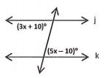

Example 1: Solve for x

Example 2:

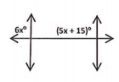

Example 3:

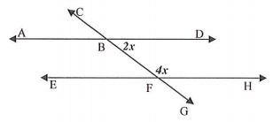

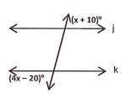Example 4:

Example 5:

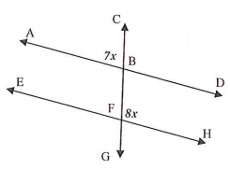

You Try: Solve the following example for x

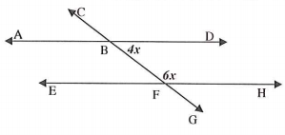

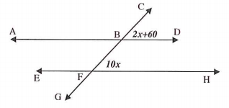

### Day 1 Homework: (2 pages)

**For problems 1 – 7, identify the special name for each angle pair.**

1

2

3

4

5

6

7

8

9

10

11

12

13

14

15

16

l

m

r

t

**1. **1 and ****4 \_\_\_\_\_\_\_\_\_\_\_\_\_\_\_\_\_\_\_\_\_\_\_

**2.** **3** and ****9 \_\_\_\_\_\_\_\_\_\_\_\_\_\_\_\_\_\_\_\_\_\_\_

**3.** ****7 and ****14 \_\_\_\_\_\_\_\_\_\_\_\_\_\_\_\_\_\_\_\_\_\_\_

**4.** ****6 and ****16 \_\_\_\_\_\_\_\_\_\_\_\_\_\_\_\_\_\_\_\_\_\_\_

**5.** ****1 and ****12 \_\_\_\_\_\_\_\_\_\_\_\_\_\_\_\_\_\_\_\_\_\_\_

**6.** ****2 and ****10 \_\_\_\_\_\_\_\_\_\_\_\_\_\_\_\_\_\_\_\_\_\_\_\_

**7.** ****7 and ****8 \_\_\_\_\_\_\_\_\_\_\_\_\_\_\_\_\_\_\_\_\_\_\_\_

**For problems 8 – 13, the figure shows l || m . Find the measures of each angle and list the angle pair name. Treat each problem independently.**

1

2

3

4

5

6

7

8

l

m

t

1. If m****1 = 120°, find m****5 = \_\_\_\_\_\_\_\_
   * **** pair name: \_\_\_\_\_\_\_\_\_\_\_\_\_\_\_\_\_\_
2. If m****6 = 72°, find m****4 = \_\_\_\_\_\_\_\_
   * **** pair name: \_\_\_\_\_\_\_\_\_\_\_\_\_\_\_\_\_\_
3. If m****2 = 64°, find m****8 = \_\_\_\_\_\_\_\_
   * **** pair name: \_\_\_\_\_\_\_\_\_\_\_\_\_\_\_\_\_\_
4. If m****4 = 112°, find m****5 = \_\_\_\_\_\_\_
   * **** pair name: \_\_\_\_\_\_\_\_\_\_\_\_\_\_\_\_\_\_
5. If m****2 = 82°, find m****7 = \_\_\_\_\_\_\_\_
   * **** pair name: \_\_\_\_\_\_\_\_\_\_\_\_\_\_\_\_\_\_
6. If m****2 = 80°, find m****5 = \_\_\_\_\_\_\_\_
   * **** pair name: \_\_\_\_\_\_\_\_\_\_\_\_\_\_\_\_\_\_

**For problems 14 – 15, the figures show p || q .**

q

t

1

2

p

1. m****1 = 3x – 15 and m****2 = 2x + 7, find x and m ****1.

x = \_\_\_\_\_\_

m****1 = \_\_\_\_\_\_

q

t

3

4

p

1. m****3 = 7x – 12 and m****4 = 12x + 2, find x and m ****4.

x = \_\_\_\_\_\_

m****4= \_\_\_\_\_\_

**For problems 13 – 14, find the values of x, y and z in each figure.**

**16. 17.**

(y+12)

(y-18)

z

x

x

(3z + 18)

3y

72°

**Day 2: Triangle Properties & Triangle Sum Theorem**

**Parts of a Triangle:**

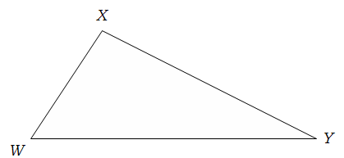Triangle – a three-sided polygon

Name –

Sides –

Vertices –

Angles –

**Classifying Triangles by Angles:**

|  |  |  |  |
| --- | --- | --- | --- |
| **Acute ∆** | **Obtuse ∆** | **Right ∆** | **Equiangular ∆** |
|  |  |  |  |

**Classifying Triangles by Sides:**

|  |  |  |
| --- | --- | --- |
| **Scalene ∆** | **Isosceles ∆** | **Equilateral ∆** |
|  |  |  |

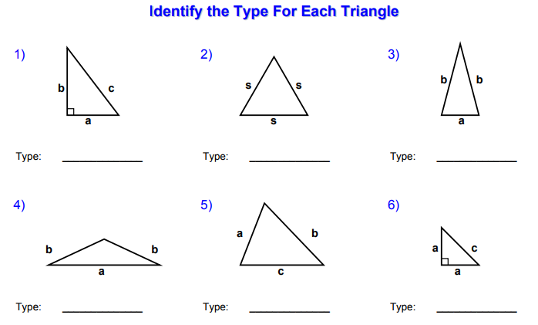

**Linear Pairs and Vertical Angles**

**Linear Pairs** – Angles that are \_\_\_\_\_\_\_\_\_\_\_\_\_\_\_\_\_\_\_\_\_ and \_\_\_\_\_\_\_\_\_\_\_\_\_\_\_\_\_\_\_\_\_\_\_\_\_\_\_\_\_\_\_\_\_\_\_\_\_.

(next to each other) (add up to equal 180°)

Use the diagram below to identify the linear pairs

\_\_\_\_\_\_ and \_\_\_\_\_\_ ; \_\_\_\_\_ and \_\_\_\_\_\_ ; \_\_\_\_\_ and \_\_\_\_\_ or \_\_\_\_\_ and \_\_\_\_\_\_.

**\*\* Property of Linear Pairs: The sum of linear pairs always equal 180° \*\***

Example: If m∠4 = 130° then m∠1 = 50° and m∠3 = 50°

If m∠3 = 35° then m∠2 =\_\_\_\_\_\_\_\_ and m∠4 = \_\_\_\_\_\_\_\_

**Vertical Angles** – A pair of non-adjacent angles formed by two \_\_\_\_\_\_\_\_\_\_\_\_\_\_\_\_\_\_\_\_\_\_ lines.



Use the diagram to identify the vertical angles

\_\_\_\_\_\_\_ and \_\_\_\_\_\_\_\_ or \_\_\_\_\_\_\_\_ and \_\_\_\_\_\_\_\_\_.

**\*\* Property of Vertical Angles: Vertical angles are always congruent \*\***

Example: If m∠1 = 70° then m∠3 = 70°

If m∠4 = 120° then m∠2 = \_\_\_\_\_\_\_\_\_\_\_\_

**Triangle Sum Theorem:**

The sum of the measures of the interior angles of a \_\_\_\_\_\_\_\_\_\_\_\_\_\_\_\_\_\_\_ is \_\_\_\_\_\_\_\_\_\_.

**Examples. Find the measure of each missing angle.**

1. 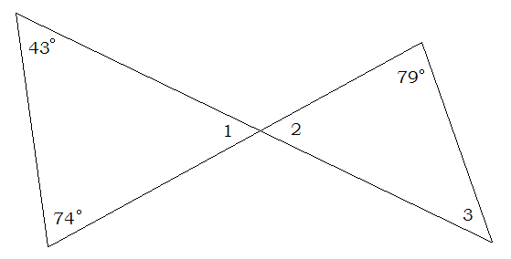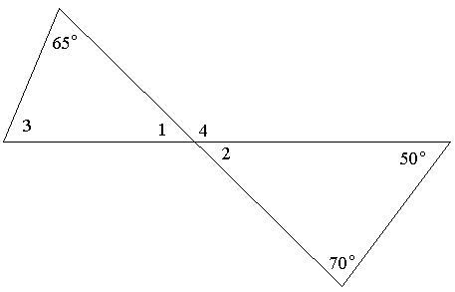 2.

**You try these. Find the measure of the indicated angle:**

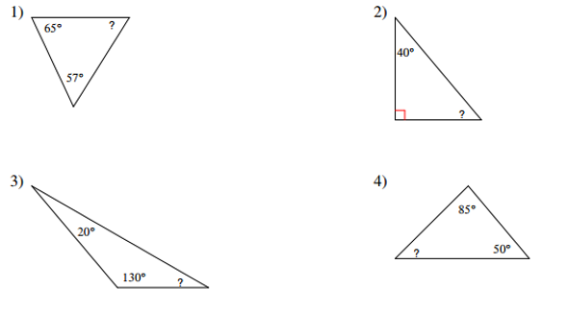

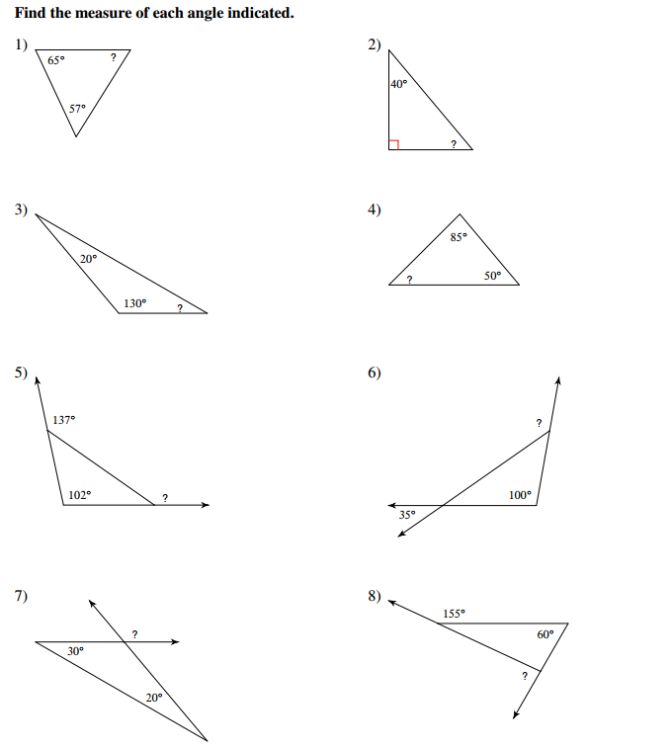**5.**

**6.**

**Triangle Sum with algebra**

**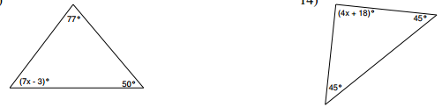 Example 1:**

**You Try 1:**



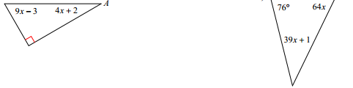

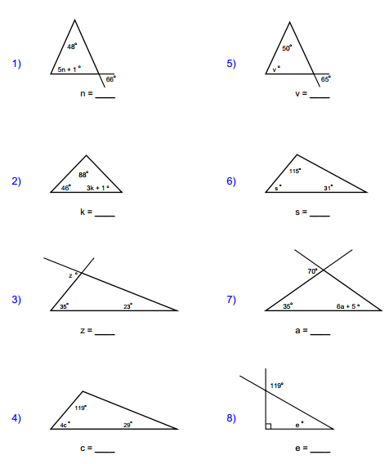**Example 2:** Use vertical angles to solve for the variable

**You Try 2:** Use vertical angles to solve for the variable

1. 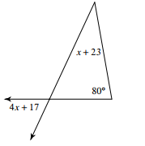
2. 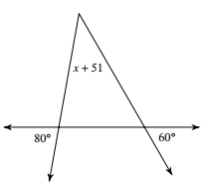

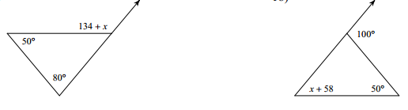**Example 3:** Use linear pairs to solve for the variable

**You Try 3:** Use linear pairs to solve for the variable

2. 

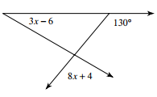

**Exterior Angle Theorem**

**Exterior Angle** – An exterior angle of a triangle is formed by any side of a triangle and the extension of its adjacent side.

∠4 is the \_\_\_\_\_\_\_\_\_\_\_\_\_\_\_\_\_\_\_\_\_\_\_\_\_\_\_\_\_\_\_\_\_

1

4 3 2

**Exterior Angle Theorem:** The measure of an exterior angle of a triangle is equal to the sum of the two remote (opposite) interior angles. (see diagram above) **m∠1 + m∠2 = m∠4**

**Example 1:** Find the measure of angle x

**You Try 1:** Find the measure of angle x

* 1. 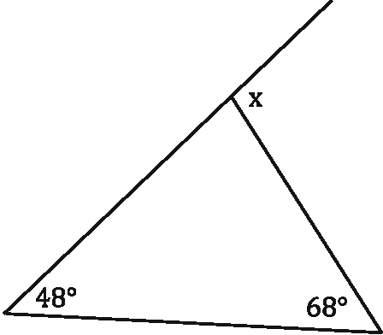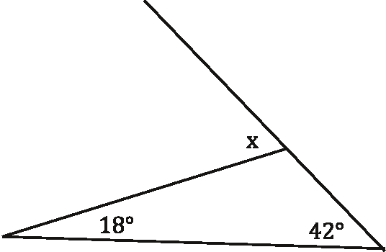 b. c.

x = \_\_\_\_\_\_\_\_\_ x = \_\_\_\_\_\_\_\_ x = \_\_\_\_\_\_\_\_\_

**Example 2:** Solve for x

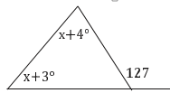

**You Try 3:** Solve for x

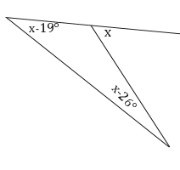 a. b. c.

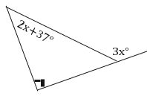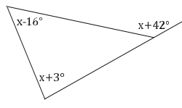

x = \_\_\_\_\_\_\_\_\_ x = \_\_\_\_\_\_\_\_ x = \_\_\_\_\_\_\_\_

**Day 2 Homework: (2 pages)**

**Find the missing angle**

1. 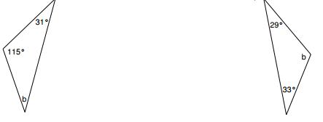
2. 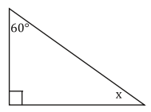
3. 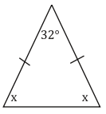

b =\_\_\_\_\_\_\_\_\_\_

x =\_\_\_\_\_\_\_\_\_\_

x=\_\_\_\_\_\_\_\_\_\_

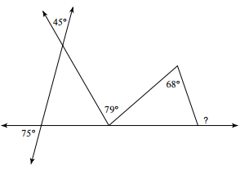

1. 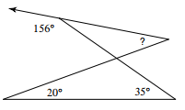

5.

? =\_\_\_\_\_\_\_\_\_\_

? = \_\_\_\_\_\_\_

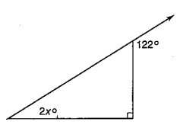Solve for x

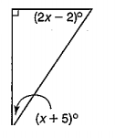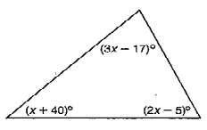6. 7. 8.

\_\_\_\_\_\_\_\_\_\_\_\_ \_\_\_\_\_\_\_\_\_\_\_\_ \_\_\_\_\_\_\_\_\_\_\_\_

Homework continue – Exterior Angle Theorem

1. 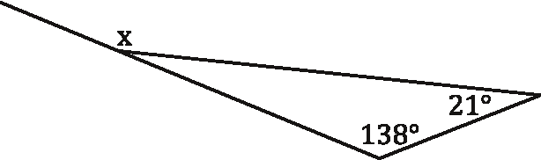
2. 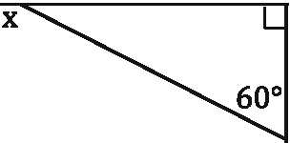
3. 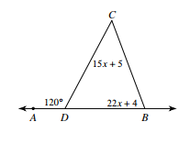
4. 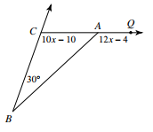
5. 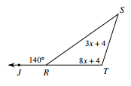
6. 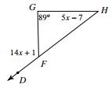
7. 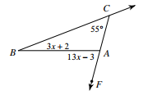
8. 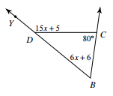

**Day 3: Determine if Triangles are Similar**

**AA ~ (Angle-Angle Similarity):** If two angles of one triangle are congruent to two angles of another, then the triangles must be similar.



**SSS ~ (Side-Side-Side Similarity):** If the lengths of the corresponding sides of two triangles are proportional, then the triangles must be similar.

**SAS ~ (Side-Angle-Side Similarity)**: If an angle of one triangle is congruent to an angle of a second triangle and the lengths of the sides including these angles are proportional, then the triangles must be similar.

Examples: Are triangles similar? If so, write the similarity statement and justify.





3.



2. 4.

**Example 5:**

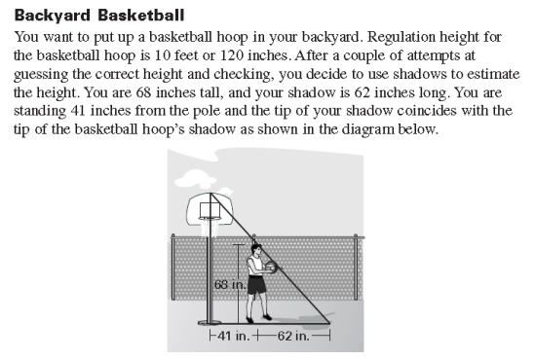

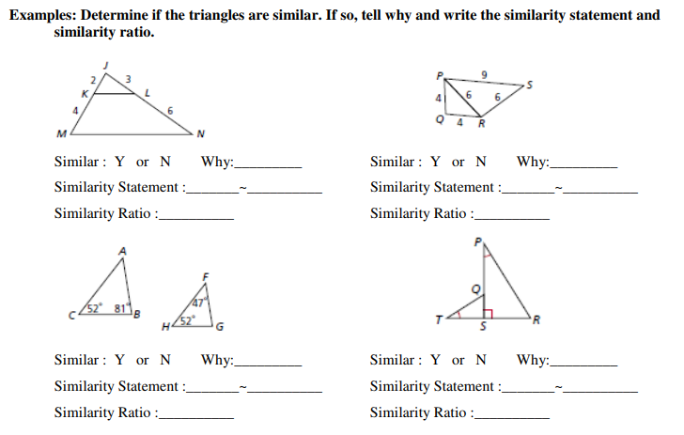

**Day 3 Homework:**

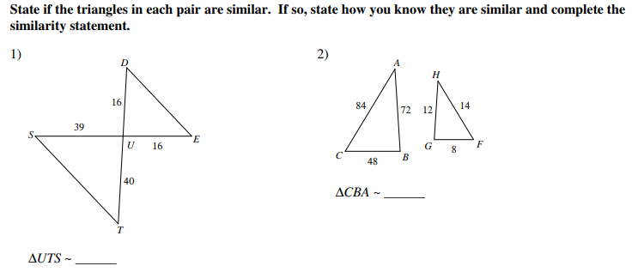

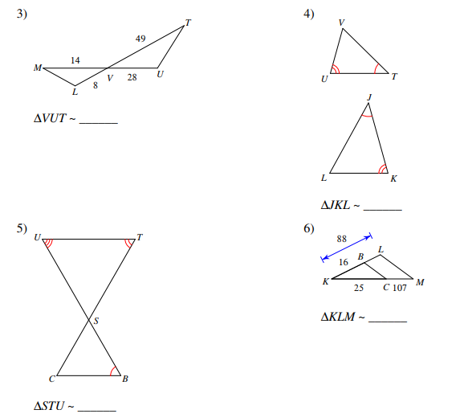

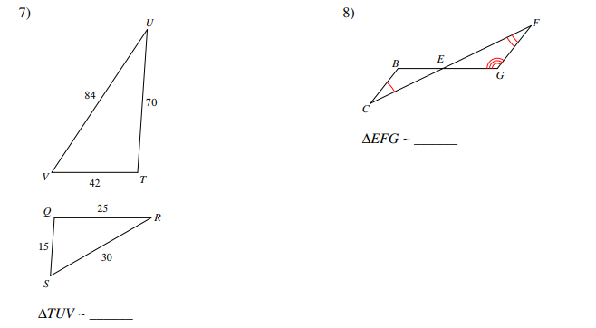

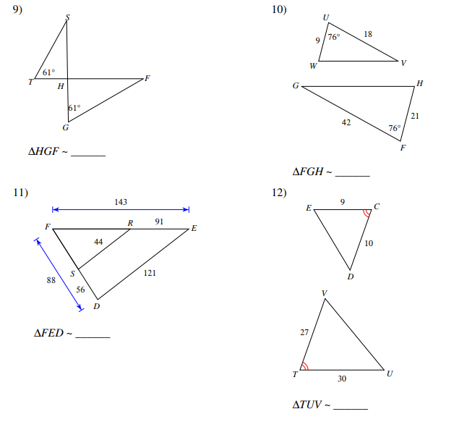

**Day 4: Introduction to Proofs**

### Properties of Equality for Real Numbers

Using the word bank, write each property next to its corresponding definition.

Word Bank:

* Transitive Property
* Reflexive Property
* Symmetric Property
* Distributive Property
* Substitution Property (Simplifying Property)
* Addition/Subtraction Properties
* Multiplication/Division Properties

|  |  |
| --- | --- |
|  | If two things are equal, then you can add/subtract the same thing on both sides of the equal sign (e.g., if *a* = *b*, then *a* + *c* = *b* + *c* and *a* – *c* = *b* – *c)*. |
|  | If two things are equal, then you can multiply/divide the same thing on both sides of the equal sign (e.g.,  if *a* = *b*, then  and . |
|  | If *a* = *b*, then *a* may be replaced by *b* in any equation or expression. |
|  | *a* (*b* + *c*) = *ab* + *ac*. |
|  | If *a* = *b* and *b* = *c*, then *a* = *c*. |
|  | Everything is equal to itself (e.g., *3* = *3)*. |
|  | If two things are equal, you can write that equality “either way” (e.g. if *a* = *b*, then *b* = *a).* |

### Algebra Proofs

**Proof** – a set of statements (and reasons) that lead to a logical conclusion.

**Algebraic Proof** – an algebra equation that is solved using the “two-column proof” format.

Ex. 1) Given: 

Prove: 

Statements Reasons .

1. 1.

2. 2.

3. 3.

4. 4.

5. 5.

Ex 2) Given: 

Prove: 

Statements \_\_\_\_\_\_\_ Reasons\_\_\_\_\_\_\_\_\_\_\_\_\_\_\_\_\_\_\_\_\_\_\_\_\_\_\_\_\_\_

1. 1.

2. 2.

3. 3.

4. 4.

5. 5.

6. 6.

7. 7.

8. 8.

Guided Notes for Proving Triangles Similar

Ex 1) Given: $\overline{JK}//\overline{MN}$

Prove: ΔJKL ~ ΔNML

Statements Reasons .

1. 1.

2. 2.

3. 3.



Ex 2) Given: $\frac{JL}{LN}=\frac{KL}{LM}$

Prove: ΔJKL ~ ΔNML

Statements Reasons .

1. 1.

2. 2.

3. 3.



Ex 3) Given: $\frac{AB}{DE}=\frac{AC}{DC}=\frac{BC}{EC}$

Prove: ∡A = ∡D

Statements Reasons .

1. 1.

2. 2.

3. 3.

Ex 4) Given: $\frac{XF}{XS}=\frac{XE}{XR}$

Prove: ∡XFE ≅ ∡S

Statements \_\_\_\_\_\_\_ Reasons\_\_\_\_\_\_\_\_\_\_\_\_\_\_\_\_\_\_\_\_\_\_\_\_\_\_\_\_\_\_

1. 1.

2. 2.

3. 3.

Ex 5) Given:

Prove: $ΔJIG\sim ΔJZY$

$\frac{JG}{JY}=\frac{GI}{YZ}$

Statements \_\_\_\_\_\_\_ Reasons\_\_\_\_\_\_\_\_\_\_\_\_\_\_\_\_\_\_\_\_\_\_\_\_\_\_\_\_\_\_

1. 1.

2. 2.

3. 3.

4. 4.

**Day 4 Homework:**

1. Given: $∠B≅∠C$

Prove: $ΔBNM\sim ΔCLM$

Statements \_\_\_\_\_\_\_ Reasons\_\_\_\_\_\_\_\_\_\_\_\_\_\_\_\_\_\_\_\_\_\_\_\_\_\_\_\_\_\_

1. 1.

2. 2.

3. 3.

1. Given:

Prove:

Statements \_\_\_\_\_\_\_ Reasons\_\_\_\_\_\_\_\_\_\_\_\_\_\_\_\_\_\_\_\_\_\_\_\_\_\_\_\_\_\_

1. 1.

2. 2.

3. 3.

4. 4.



1. Given: $∠D$ and $∠AHE$ are right angles

Prove: (1) The two triangles are similar.

(2) $∠G≅∠AEH$

Statements \_\_\_\_\_\_\_ Reasons\_\_\_\_\_\_\_\_\_\_\_\_\_\_\_\_\_\_\_\_\_\_\_\_\_\_\_\_\_\_

1. 1.

2. 2.

3. 3.

4. 4.

1. Given:

Prove:

Statements \_\_\_\_\_\_\_ Reasons\_\_\_\_\_\_\_\_\_\_\_\_\_\_\_\_\_\_\_\_\_\_\_\_\_\_\_\_\_\_

1. 1.

2. 2.

3. 3.

4. 4.



1. Given:

Prove:

Statements \_\_\_\_\_\_\_ Reasons\_\_\_\_\_\_\_\_\_\_\_\_\_\_\_\_\_\_\_\_\_\_\_\_\_\_\_\_\_\_

1. 1.

2. 2.

3. 3.

1. Given:

Prove:

Statements \_\_\_\_\_\_\_ Reasons\_\_\_\_\_\_\_\_\_\_\_\_\_\_\_\_\_\_\_\_\_\_\_\_\_\_\_\_\_\_

1. 1.

2. 2.

3. 3.

Day 5: Triangle Midsegment Theorem

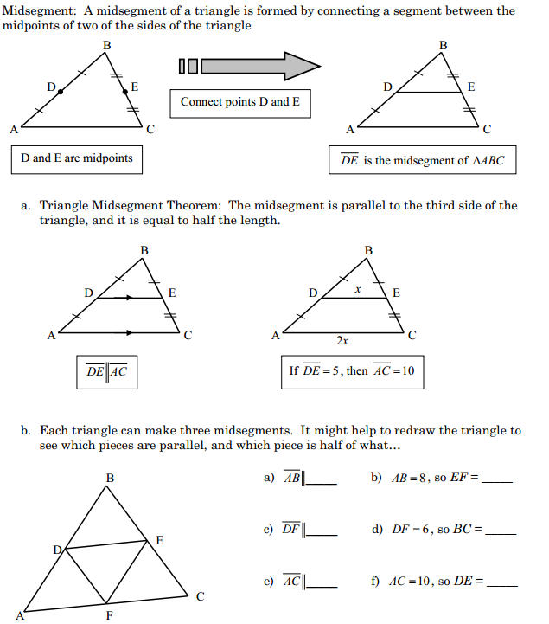

Examples:

1. If PQ = 8, BC = \_\_\_\_\_\_\_\_.
2. If BC = 8, PQ = \_\_\_\_\_\_\_\_.
3. If AP = 12, PB = \_\_\_\_\_\_\_\_ and AB = \_\_\_\_\_\_\_\_.
4. If BC = x + 9 and PQ = 5x, then x = \_\_\_\_\_\_\_\_, PQ = \_\_\_\_\_\_\_\_\_, and BC = \_\_\_\_\_\_\_\_.
5. If PQ = x + 12 and BC = x2, then x = \_\_\_\_\_\_\_\_, PQ = \_\_\_\_\_\_\_\_, and BC = \_\_\_\_\_\_\_\_.

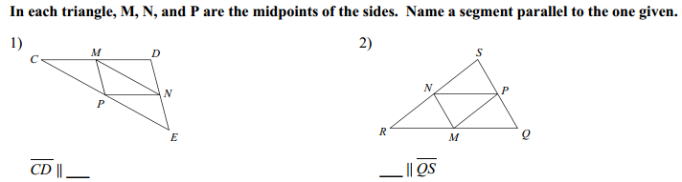

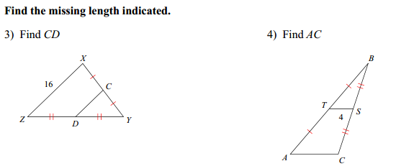

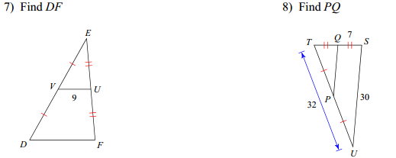

**Homework:**

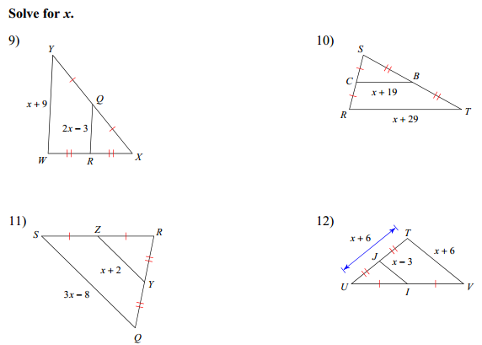

17) 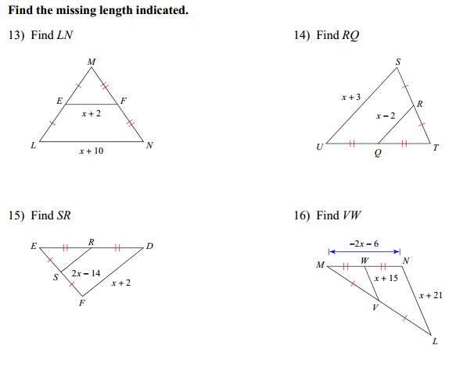

**Day 6: Triangle Proportionality**

**Practice with the Δ Proportionality Theorem**

**Ex. 1**  **Ex. 2**

P

A

Y

E

S

L

R

V

I

D

E

O

  



  

Now that you can write the proportions, you can solve problems.



**Ex. 3 Ex. 4 Ex. 5**

V

I

D

E

O

x

5

8

20

x

x

***Solve for the variable in each figure.***

*k*

923

4

12

5

23

*5y – 2*

3*x* + 2

*x*

10

1. *y* =\_\_\_\_\_\_\_\_\_\_ 2. *k* =\_\_\_\_\_\_\_\_\_\_\_\_\_\_

*x* = \_\_\_\_\_\_\_\_\_\_

3. SQ = *x* ; ST = 22 ; 4. *y* =\_\_\_\_\_\_\_\_\_\_

SP = 12 ; PR = 4*x*+8

8

*y*3

*x*

5

20

16

*x* = \_\_\_\_\_\_\_\_\_\_

*x* =

$\overline{PQ}//\overline{RT}$

 \_\_\_\_\_\_\_\_\_\_

More practice:

1. Parallelogram EFGH is similar to parallelogram WXYZ.

Y

X

G

F

6 in

2 in

3 in

H

E

W

Z

What is the length of ?

a) 3 in b) 6 in c) 7 in d) 9 in

2. Lance the alien is 5 feet tall. His shadow is 8 feet long.

na01683_

bd18253_

bd07609_

5 ft

32 ft

8 ft

At the same time of day, a tree’s shadow is 32 feet long. What is the height of the tree?

a) 20 feet b) 24 feet c) 29 feet d) 51 feet

X

?

3. Pentagon JKLMN is similar to pentagon VWXYZ.

What is the measurement of angle X?

L

60°

Y

W

a) 30° b) 60° c) 150° d) 120°

M

K

150°

J N V Z

4. Triangle LMN is similar to triangle XYZ.

L

Z

8 feet

24 feet

18 feet

Y X

N 12 feet M

What is the length of ?

a) 2 feet b) 3 feet c) 4 feet d) 6 feet

5. Triangle PQR is similar to triangle DEF as shown.

E

Q

4 cm

6 cm

P 6 cm R

D 9 cm F

Which describes the relationship between the corresponding sides of the two triangles?

a)  b)  c)  d) 

1. A six-foot-tall person is standing next to a flagpole. The person is casting a shadow  feet in length, while the flagpole is casting a shadow 5 feet in length. How tall is the flagpole?

a) 30 ft b) 25 ft c) 20 ft d) 15 ft

Y

7. ΔPQR is similar to ΔXYZ.

Q

30

6

5

R

10

Z

P

X

What is the perimeter of ΔXYZ?

a) 21 cm b) 63 cm c) 105 cm d) 126 cm

8. The shadow cast by a one-foot ruler is 8 inches long. At the same time, the shadow cast by a pine tree is 24 feet long.

bd18253_

24 feet

What is the height, in feet, of the pine tree?

a) 3 feet b) 16 feet c) 36 feet d) 192 feet

8 inches

1 foot

**Day 6 Homework: (2 pages)**



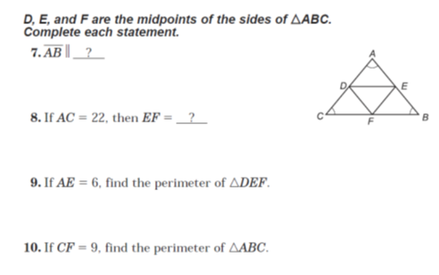

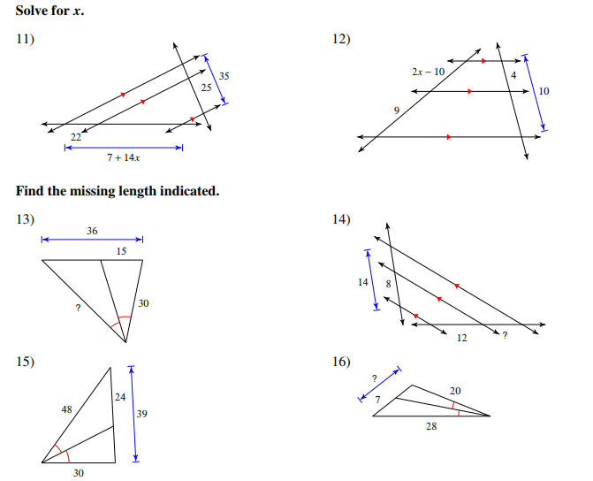

**Day 7: Unit Review**

1

2

3

4

5

6

7

8

9

10

11

12

13

14

15

16

l

m

r

t

**For problems 6 – 12, identify the special name for each angle pair.**

1. 1 and 9 \_\_\_\_\_\_\_\_\_\_\_\_\_\_\_\_\_\_\_\_\_\_\_

2. 3 and 10 \_\_\_\_\_\_\_\_\_\_\_\_\_\_\_\_\_\_\_\_\_\_\_

3. 7 and 13 \_\_\_\_\_\_\_\_\_\_\_\_\_\_\_\_\_\_\_\_\_\_\_

4. 6 and 16 \_\_\_\_\_\_\_\_\_\_\_\_\_\_\_\_\_\_\_\_\_\_\_

5. 11 and 14 \_\_\_\_\_\_\_\_\_\_\_\_\_\_\_\_\_\_\_\_\_\_\_

6. 2 and 3 \_\_\_\_\_\_\_\_\_\_\_\_\_\_\_\_\_\_\_\_\_\_\_\_

7. ****7 and ****8 \_\_\_\_\_\_\_\_\_\_\_\_\_\_\_\_\_\_\_\_\_\_\_\_

q

t

7x – 12

12x + 2

p

q

t

3x – 15

2x + 7

p

1. **Solve for x**
2. **Solve for x**

**x** = \_\_\_\_\_\_\_\_\_ x = \_\_\_\_\_\_\_

y

65°

3x + 5

3y + 12

2x + 40

y

10. 11.

x = \_\_\_\_\_\_\_\_, y = \_\_\_\_\_\_\_\_ x = \_\_\_\_\_\_\_\_, y = \_\_\_\_\_\_\_\_\_\_

12. w = \_\_\_\_\_\_\_\_, x = \_\_\_\_\_\_\_\_, y = \_\_\_\_\_\_\_\_\_ 13. x = \_\_\_\_\_\_\_\_\_

8x + 6

11x +3

6x

84˚

2w

5y-4

**Solve for x**

14. x = \_\_\_\_\_\_\_\_\_\_ 15. x = \_\_\_\_\_\_\_\_\_\_

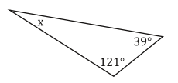 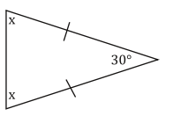

16. 17.

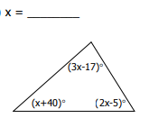 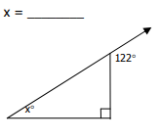

18. x = \_\_\_\_\_\_\_\_ 19. x = \_\_\_\_\_\_\_\_\_

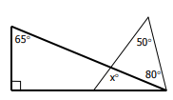 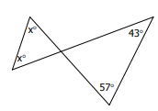

1

3

5

2

4

20. **Find m∠3** if m∠5 = 130 and m∠4 = 70.

6

8

7

10

11

9

21. If **m∠6 = x**, **m∠7 = x – 20**, and **m∠11 = 80**,

then x = \_\_\_\_\_.

22. Solve for x

140°

x°

35°

x = \_\_\_\_\_\_\_\_\_\_\_

23. Solve for x

x°

(3x + 54)º

(4x)°

x = \_\_\_\_\_\_\_\_\_\_\_

24.Find m∠1=\_\_\_\_\_\_ , m∠2=\_\_\_\_\_\_\_ , m∠3=\_\_\_\_\_\_\_ , m∠4=\_\_\_\_\_\_\_\_ , and m∠5=\_\_\_\_\_\_\_.

46°

65°

82°

142°

1

2

5

4

3

