Unit 3 : Quadratic Functions

Math 2

Spring 2018

|  |  |
| --- | --- |
| **The Real Number System**  ***Use properties of rational and irrational numbers.*** | |
| NC.M2.N-RN.3 | Use the properties of rational and irrational numbers to explain why:   * the sum or product of two rational numbers is rational; * the sum of a rational number and an irrational number is irrational; * the product of a nonzero rational number and an irrational number is irrational. |
| **The Complex Number System**  ***Defining complex numbers.*** | |
| NC.M2.N-CN.1 | Know there is a complex number *i* such that 𝑖2 = – 1, and every complex number has the form 𝑎 + 𝑏𝑖 where 𝑎 and 𝑏 are real numbers. |
| **Seeing Structure in Expressions**  ***Interpret the structure of expressions.*** | |
| NC.M2.A-SSE.1  NC.M2.A-SSE.1a | Interpret expressions that represent a quantity in terms of its context.   1. Identify and interpret parts of a **quadratic**, square root, **inverse variation**, or right triangle trigonometric expression, including terms, factors, coefficients, radicands, and exponents. |
| NC.M2.A-SSE.1b | 1. Interpret **quadratic** and square root expressions made of multiple parts as a combination of single entities to give meaning in terms of a context. |
| **Arithmetic with Polynomial Expressions**  ***Perform arithmetic operations on polynomials.*** | |
| NC.M2.A-APR.1 | Extend the understanding that operations with polynomials are comparable to operations with integers by adding, subtracting, and multiplying polynomials. |
| **Arithmetic with Polynomial Expressions**  ***Understand the relationship between zeros and factors of polynomials.*** | |
| NC.M2.A-APR.3 | Understand the relationships among the factors of a quadratic expression, the solutions of a quadratic equation, and the zeros of a quadratic function. |
| **Creating Equations**  ***Create equations that describe numbers or relationships.*** | |
| NC.M2.A-CED.1 | Create equations and inequalities in one variable that represent **quadratic**, square root, **inverse variation**, and right triangle trigonometric relationships and use them to solve problems. |
| NC.M2.A-CED.2 | Create and graph equations in two variables to represent **quadratic**, square root and **inverse variation** relationships between quantities |
| NC.M2.A-CED.3 | Create systems of **linear, quadratic**, square root, and inverse variation equations to model situations in context. |
| **Reasoning with Equations and Inequalities**  ***Understand solving equations as a process of reasoning and explain the reasoning.*** | |
| NC.M2.A-REI.1 | Justify a chosen solution method and each step of the solving process for **quadratic**, square root and **inverse variation** equations using mathematical reasoning. |
| **Reasoning with Equations and Inequalities**  ***Solve equations and inequalities in one variable.*** | |
| NC.M2.A-REI.4  NC.M2.A-REI.4a | Solve for all solutions of quadratic equations in one variable.   1. Understand that the quadratic formula is the generalization of solving 𝑎𝑥2 + 𝑏𝑥+ 𝑐 by using the process of completing the square. |
| NC.M2.A-REI.4b | 1. Explain when quadratic equations will have non-real solutions and express complex solutions as 𝑎 ± 𝑏𝑖 for real numbers 𝑎 and 𝑏. |
| **Reasoning with Equations and Inequalities**  ***Solve systems of equations.*** | |
| NC.M2.A-REI.7 | Use tables, graphs, and algebraic methods to approximate or find exact solutions of systems of linear and quadratic equations, and interpret the solutions in terms of a context. |
| **Building Functions**  ***Build a function that models a relationship between two quantities.*** | |
| NC.M2.F-BF.1 | Write a function that describes a relationship between two quantities by building **quadratic functions with real solution(s)** and **inverse variation functions** given a graph, a description of a relationship, or ordered pairs (include reading these from a table). |

**Day 1: Factoring Quadratics**

Step 1: Put equation in Standard Form ax2 + bx + c = 0

Step 2: Find GCF and factor it out

Step 3: Make an X and put **ac** on top and **b** at the bottom of the X

Then, find two numbers that **multiply to make ac and add to make b** and put it on the left and right

of the X

ac

b

Step 4: Write the two numbers as factors (x + # ) or (x – #)

Step 5: Divide the factors by **a** and reduce the fraction if possible

Then, move the denominator to the front of the x

Example 1. x2 + 8x + 15 = 0

Example 2. x2 + 2x – 8 = 0

Example 3. x2 + 2 = 3x

You Try:

4. 4x2 + 8x + 3 = 0

5. 3k2 + 72 = 33k

**Classwork:** Factor the following.

1. 16n2 – 114n = -14 2. 28n2 = -96 – 184n

3. 7a2 + 32 = 7 – 40a 4. 42x2 – 69x + 20 = 7x2 - 8

5. 7v2 – 42 = -35v 6. n2 = -18 – 9n

**Day 1 Homework:**

**Factor the GCF FIRST, then factor the polynomial, if possible.**

|  |  |
| --- | --- |
| 1. Factor completely: | 1. Factor completely: |
| 1. What is the greatest common factor of  and ? | 1. Factor completely: |
| 1. Factor completely: | 1. What is the greatest common factor of  and ? |
| 1. Factor completely: | 1. Factor Completely: |

**Day 2: Polynomials**

**Definition: Polynomials –**

You can add, subtract, multiply or divide polynomials

Simplify the following polynomial according to the directions given below.

i. f(x) = 3p2 - 2p + 3 and g(x) = p2 - 7p + 7

Sum:­__________________________________ Difference: ____________________________________

ii. f(x) = 7x2 - 8 and g(x) = 3x2 + 1

Sum:­__________________________________ Difference: ____________________________________

iii. 

Sum:­__________________________________ Difference: ____________________________________

iv. 

Sum:­__________________________________ Difference: ____________________________________

v. 

Sum:­__________________________________ Difference: ____________________________________

vi. 

Sum:­__________________________________ Difference: ____________________________________

b. Explain in your own words how to find the simplest rule for the sum or difference of two polynomials.

**INVESTIGATION: POLYNOMIALS IN CONTEXT**

1. 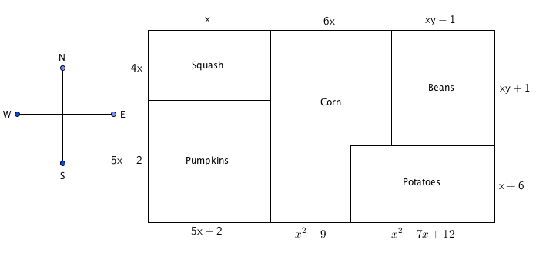Farmer Bob is planting a garden this spring. He wants to plant squash, pumpkins, corn, beans, and potatoes. His plan for the field layout in feet is shown in the figure below. Use the figure and your knowledge of polynomials, perimeter, and area to solve the following:

a. Write an expression that represents the length of the south side of the field.

b. Simplify the polynomial expression that represents the south side of the field.

c. Write a polynomial expression that represents the perimeter of the pumpkin field.

d. Simplify the polynomial expression that represents the perimeter of the pumpkin field. State one reason why the perimeter would be useful to Farmer Bob.

e. Write a polynomial expression that represents the area of the potato field.

f. Simplify the polynomial expression that represents the area of the potato field. State one reason why the calculated area would be useful to Farmer Bob.

**Day 2 Homework:**

|  |  |
| --- | --- |
| 1. Simplify: | 2. Multiply: |
| 3. Compute the product: | 1. Multiply to remove the parenthesis: |
| 1. Simplify: | 1. Simplify: |

Multiply the following polynomials.

|  |  |
| --- | --- |
| 7. | 8. |
| 9. | 10. |
| 11. Simplify | 12. What is the product of  and |
| 13. The expression  is equivalent to  (1)  (3)  (2)  (4) | 14. The expression  is equivalent to  (1)  (3)  (2)  (4) |

**Day 3: Solve by Factoring**

**To SOLVE by factoring**:

**Step 1:** Factor the polynomial

**Step 2:** Set each factor = to zero

**Step 3:** Solve for the variable

Examples:

1. 2b2 + 17b + 21=0 2. 7x2 = 45x + 28

**Factor and solve Difference of Squares:**

**Difference of Squares: If there are only two terms to be factored** AND **both of them are ___________ ____________** AND **they are being _______________then you can use the shortcut to factor:**

**(a2 – b2) = (_______________) (______________)**

**Example #1.** X2 – 49 = 0 **Example #2.** 4x2 – 81 = 0

Day 3 Classwork – Solving by Factoring

**Classwork:** Solve each of the following by factoring

1) 2)

3) 4)

5) 5)

6) (Hint: Must use difference of square twice)

7) 8)

9) 10)

11) 12)

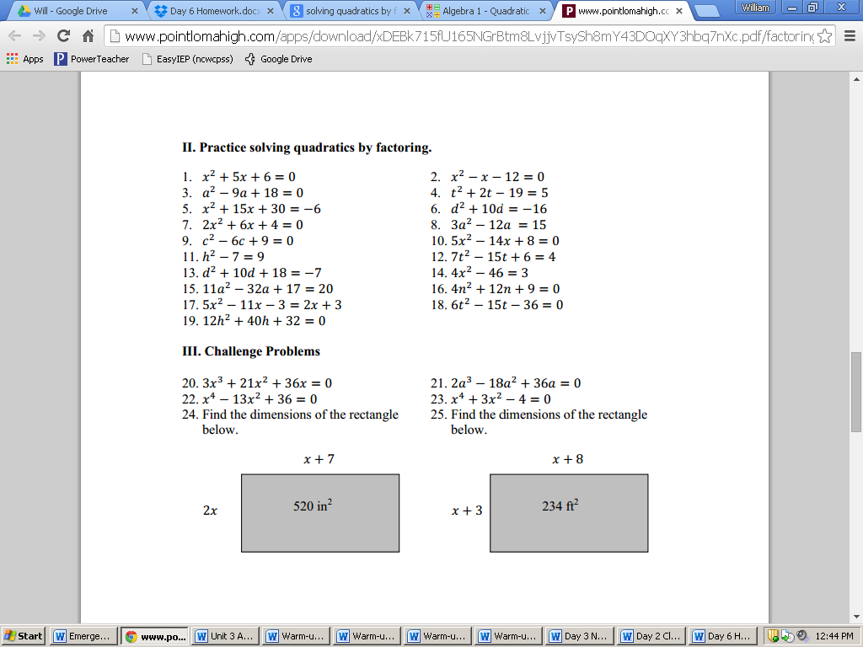13) Find the dimension of the rectangle 14) Find the dimension of the rectangle



**Day 3 Homework** – Solving by Factoring

1. 4x2 – 46 = 3 2. 11a2 – 32a + 17 = 20

3. 3x3 + 21x2 + 36x = 0 4. 2a3 – 18a2 + 36a = 0

5. 7x2 = 32x + 60 6. 81x2 – 16 = 0

7. 4x3 = -43x2 – 30x 8. m2 = 100

9. 7v2 – 42 = -35v 10. -5n2 + 6n – 16 = -5n2

**Day 4: Quadratic Formula**

Quadratic Formula – Factoring will not always work, but quadratic formula works for everything!

**Quadratic Formula: x = $\frac{-b ± \sqrt{b^{2} - 4ac}}{2a}$**

**where a, b, and c are from the standard equation ax2 + bx + c = 0**

Example 1: 8x2 – 4x – 18 = 0

Example 2: 9x2 – 11 = 6x

Example 3: 4a2 – 8 = a

Day 4 Classwork – Quadratic Formula

**You try!**

1. v2 + 2v – 8 = 0 2. 4x2 + 4x – 8 = 1

**Classwork:**

Solve using quadratic formula.

1. k2 + 5k – 6 = 0 2. x2 + x = 4

3. 10k2 + 200k + 937.5 = 0 4. 4x2 + 8x + -77 = 0

5. 16y2 + -8y + -3 = 0 6. x2 + -1.375x + 0.375 = 0

**Day 4 Homework** – Quadratic Formula

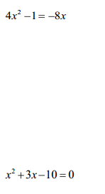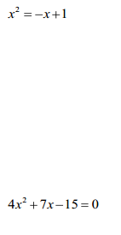Solve each of the following by using the quadratic formula.

1. 2.

3. 4.

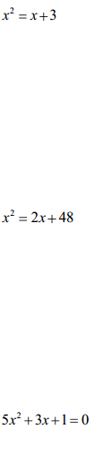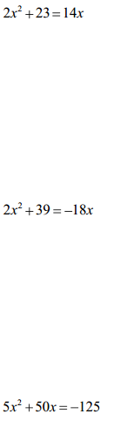

5. 6.

7. 8.

9. 10.

Day 5 Classwork – Solving Quadratics Practice

**Solve the following by Factoring or use Quadratic Formula.**

1. 2.

3. 4.

5. x2 – 7x – 18 = 0 6. p2 – 5p = 14

7. 7x2 – 31x = 20 8. 28n4 = -16n3 + 80n2

**Day 5 Homework** – Solving Quadratics Practice

Factor and solve the following

1)  2) 

3)  4) 

5)  6) *x*2 + *x* = 12

Use Quadratic Formula to solve the following:

7)  8) 5*x*2 – 8*x* = -3

9) 3*x*2 = 7 – 2*x* 10) x2 – 10x + 25 = 16

**Day 6: The Discriminant**

**Discriminant: quickly tells us how many solutions (or x-intercepts) a quadratic will have.**

**Discriminant = b2 – 4ac**

**If the discriminant is positive, there are _____solution(s).**

**If the discriminant is negative, there are ______ solution(s)**

**If the discriminant is zero, there are ______ solution(s).**

Example 1: Tell how many solutions and what type of solutions y = 7x2 – 45x – 28 has.

Example 2: Tell how many solutions and what type of solutions 2x2 + 5 + 20x = -11 - 2x2 + 4x has.

Example 3: Tell how many solutions and what type of solutions z2 + 0.6z - 20.16 = 0 has.

You Try:

1. Tell how many solutions and what type of solutions y = 8x2 +6x +5 has.
2. Tell how many solutions and what type of solutions k2 + -10k + 45 = 7k + -35 has.

3. Tell how many solutions and what type of solutions  has.

**Day 6 Homework** – Discriminant

**Find the discriminant and use it to describe the number of roots/solutions for the quadratic equation.**

1) 2)

3) 4)

5) 6)

7) 8)

9) 10)

11) 12)

**Day 7: Imaginary and Complex Numbers**

**Imaginary Numbers**

You cannot take the square root of a negative number. In order to simplify it you must use imaginary numbers.

Example 1:

$\sqrt{-4}$

Example 2:

$\sqrt{-25}$

You Try 1:

$\sqrt{-36}$

**Complex Numbers**

A complex number is in the form $a+bi$ where **a** and **b** get replaced by numbers.

Example 3: Simplify the expression

$\frac{10±\sqrt{-64}}{2}$

Example 4: Simplify the expression

$\frac{24±\sqrt{-81}}{3}$

You Try 2: Simplify the expression

$\frac{-28±\sqrt{-196}}{7}$

You Try 3: Simplify the expression

$\frac{30±\sqrt{-400}}{5}$

**Quadratics with Complex Solutions**

Example 5: Solve using the quadratic formula

x2 – 10x + 29 = 0

Example 6: Solve using the quadratic formula

4x2 + 16 = 0

You Try 4: Solve using the quadratic formula

x2 – 4x + 13 = 0

You Try 5: Solve using the quadratic formula

3x2 – 18x + 30 = 0

**Day 7 Homework:**

**Simplify the following imaginary numbers.**

$\sqrt{-121}$

$\sqrt{-49}$

$\sqrt{-200}$

**Solve the following quadratics using the quadratic formula. Leave your answers as complex numbers.**

1. **2x2 – 6x + 5 = 0**
2. **8x2 – 4x + 5 = 0**
3. **-5x2 + 12x – 8 = 0**
4. **5x2 + 8x + 5 = 0**
5. **5x2 + 12x + 8 = 0**
6. **-x2 + 4x – 5 = 0**

**Day 8: Solve Systems of Linear and Quadratics**

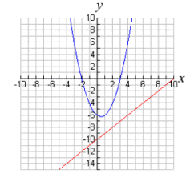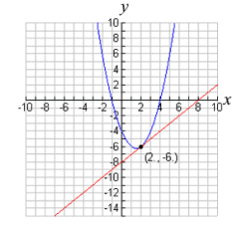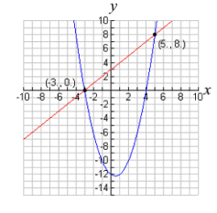If you were to graph a quadratic function and a linear function, there are 3 possibilities.

_______________ ___________________ __________________

Example 1. Solve this system algebraically

y = x2 – x – 6

y = 2x – 2

Example 2. Solve the system.

x2 + y2 = 25

4y = 3x

You Try: Solve the system

x2 + y2 = 26

x –y = 6

You Try: Solve the system.

y = 2x2 + 14x – 15

y = 3x + 25

**Practice: Solve the following systems**

3. y = x2 + 4x + 3

y = 2x + 6

4. y = -x2 + 2x + 4

x + y = 4

Example 3:

A rocket is launched from the ground and follows a parabolic path represented by the equation y = −x2 + 10x . At the same time, a flare is launched from a height of 10 feet and follows a straight path represented by the equation y = −x + 10. Find the coordinates of the point or points where the paths intersect.

Example 4: A pelican flying in the air over water drops a crab from a height of 30 feet. The distance the crab is from the water as it falls can be represented by the function h(t) = −16t2 + 30, where t is time, in seconds. To catch the crab as it falls, a gull flies along a path represented by the function g(t) = −8t + 15. Can the gull catch the crab before the crab hits the water?

**Day 8 Homework:**

Solve the following systems.

1. y = x2 – 7x + 13 2. y = -x2 + 4x – 3

x – y = 2 x + y = 1

3. A punter kicks a football. Its height, *h*, in metres, *t* seconds after the kick is given by the equation

*h* = -4.9*t2*+18.24*t* + 0.8. The height of an approaching blocker’s hands is modelled by the equation *h* = -1.43*t* + 4.26 ,

using the same time. Can the blocker knock down the punt? If so, at what point will it happen?

4. The height, *h*, of a baseball, in metres, at time *t* seconds after it is tossed out of a window is modeled by

*h* = -5*t2* + 20*t* +15. A boy shoots at the baseball with a paintball gun. The trajectory of the paintball is given by the equation *h* = 3*t* + 3 . Will the paintball hit the baseball? If so, when? At what height will the baseball be?

**Day 9: Quadratic Inequalities**

Review from Previous Math course:

Solve and graph the inequality 3x + 5 $≤$ 23 (graph on a number line)

Solve and graph the inequality -2x – 21 < 17 (graph on a number line)

**Steps to solving Quadratic Inequalities**:

1. Move all terms to one side and set the expression equal to zero.

2. Simplify and factor the quadratic expression or use the quadratic formula to find the roots/solutions.

(Find the roots/solutions is to solve for the variable).

4. Place the roots (solutions) on the number line to divide the number line into 3 intervals.

5. Test the interval that has zero to see if it **makes the inequality true**.

(test by substituting zero into the inequality)

**If it is true then the solutjons are in that interval.**

**If it is not true then the solutions are in the other two intervals.**

If middle interval works : **shade inside the parabola**

If end intervals work: **shade outside of the parabola**

**Quadratic Inequalities**

**Example #1. Find the solutions to the quadratic Inequality.**

x2 + x – 12 -6

First Interval __________ Second Interval __________ Third Interval _____________

Solutions ____________________________

**Example #2.** Find and graph the solution.

x2 + 10x + 25 > 9

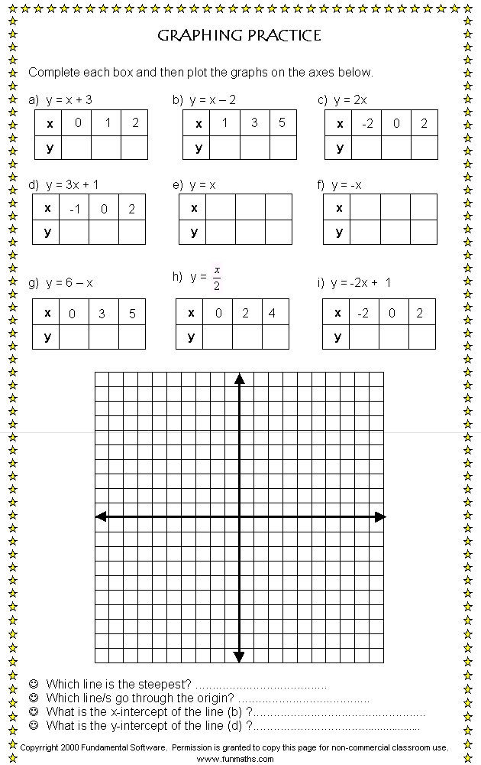

**You Try #1.** Find and graph the solution.

x2 – x + 24 > 36

**Example #3:**

The annual profit, p(x), in dollars of a company varies with the number of employees, x, as

**p(x)= -40x2 + 4400x**. What is the range of the number of employees for which the company’s annual profit will be **at least $112,000**?

**Example #4:**

The profit a coat manufacturer makes each day is modeled by the equation ** ,** where P is the profit and x is the price for each coat sold. For what values of x does the company **make a profit**?

**You Try #1:** When a baseball is hit by a batter, the height of the ball, H, at time t, (t  0) , is determined by the equation ** .** For which interval of time is the height of the ball **greater than or equal to 52 feet**?

**You Try #2:** The height of a punted football can be modeled by the function ****, where H is given in meters and the time x is in seconds. At what time in its flight is the ball **within 5 meters of the ground?**

**Practice:**

1. The height of a ball above the ground after it is thrown upwards at 40 feet per second can be modeled by the function , where the height, H, is given in feet and the time x is in seconds. At what time in its flight is the ball within 15 feet of the ground?

2. A rectangle is 6 cm longer than it is wide. Find the possible dimensions if the area of the rectangle is more than 216 square centimeters.

3. Karen wants to plant a garden and surround it with decorative stones. She has enough stones to enclose a rectangular garden with a perimeter of 68 feet, but she wants the garden to cover no more than 240 square feet. What could the width of her garden be?

4. A manilla rope used for rappelling down a cliff can safely support a weight W (in pounds) provided



Where d is the rope’s diameter (in inches). What diameter of rope would be needed to support a weight of

at least 5920 pounds?

**Day 9 Homework:**

Graph each Quadratic Inequality:

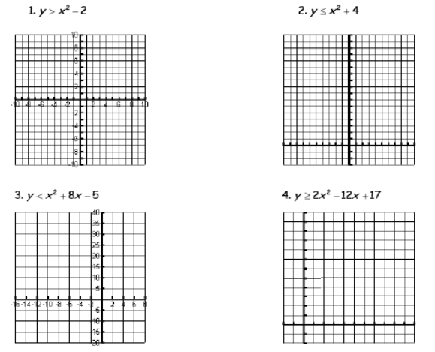

Solve each quadratic inequality:

|  |  |
| --- | --- |
| $x^{2}-x-20>0$ | $9x^{2}+31x+12≤0$ |
| $x^{2}-10x+8<-8$ | $9z≤12z^{2}$ |
| $x^{2}+5x≥24$ | $x^{2}+64≥16x$ |

**Day 10: Unit 3 Review**

**I. Polynomials:**

* **To Add or Subtract Polynomials – Combine like terms (find terms with same variables and exponents) by adding or subtracting the leading coefficients but leave the variable and exponent the same.**
* **Multiply Polynomials – multiply the leading coefficients then add the exponents of like variables.**

**Simplify the following: (#1 - #4)**

1. (8x8 - 9x3 + 3x2 + 9) + (4x7 + 6x3 - 2x – 4 ) = _______________________________________

2. (2x3 – 2y2 + 5xy - 1) - (3x3 – 7y2 + 2xy - 4) = ______________________________________

3. (2x – 1)(x + 3) =__________________________

4. 5x2y4(3x6 + 8y5 – 4w) = _____________________

5. Solve the problem.

A triangle has sides of length 4x – 5, 3x + 2y + 8, and 6x + y, **what is the perimeter of the triangle**?

**II. Factor and Solve**

**Step 1: Get the equation in standard form and equal to zero**

**Step 2: Factor out the GCF**

**Step 3: Make the X! Find 2 numbers that multiply to get a*c (Top of X) and**

**add to get b (bottom of X).**

**Step 4: Write the numbers as factors (x + ) or (x – ) and then Divide each factor by a**

**Step 5: Simplify the fraction if possible and move denominator to the front of x**

**Step 6: Set each factor equal to zero and solve for the variable**

**Factor and Solve the following: (#6 - #11) (Show your work!)**

6. m2 – 5m – 6 = 0 7. 3k2 – 3k = 7k – 3

8. 9p2 – 16 = 0 9. 5x2 = 45

10. x2 + 8x = 0 11. 3w2 = 45 – 6w

**III. Discriminant: $b^{2}-4ac$**

**If the discriminant is positive, there are 2 real solutions.**

**If the discriminant is negative, there are 2 complex solutions (no real solution).**

**If the discriminant is 0, there is 1 real solution.**

**Find the Discriminant and tell how many and what type of solutions the function has. (#12 - #15)**

12. 7x + 20 = 6x2 D = __________ _____________________________

13. 5x2 = 3x – 2 D = __________ _____________________________

14. 2x2 + 8 = 8x D = __________ _____________________________

15. -3x(x + 3) = 12 D = __________ ______________________________

**IV. Quadratic Formula $x=\frac{-b±\sqrt{b^{2}-4ac}}{2a}$ where a, b, and c are from ax2 + bx + c = 0**

**Solve for the variable using the Quadratic Formula. (#16 - #20) (Round answers to the hundredth place if necessary)**

16. p2 = 10p – 23

17. -4x2 – 4x = -9

18. m2 + 25 = -8m

19. 3x2 + 5x + 6 = 0

20. The sum of two positive, consecutive even numbers is 46 while their product is 528. Find the numbers.

**V. Solving Quadratic – Linear System**

* **On calculator: Get y by itself in both equations.**

**Input the equations into y1 and y2 on the calculator.**

**Use 2nd Function /Graph to calculate the intersection(s) of the equations.**

* **By hand: Get y by itself in both equations.**

**Set the equations equal to each other then get all terms to the same side and = 0**

**Use Quadratic Formula or factoring and solve the quadratic.**

**Substitute the x-value(s) found back into the linear equation to find y. Your solution(s) should be**

**ordered pair(s).**

**Find the solutions to the following systems of equations (#21 - #23)**

21. 



22. 

23. 

**VI. Inequalities:**

* + **Get every terms to one side and set equal to zero**
  + **Use Quadratic Formula or Factoring to find the critical values.**
  + **Place the critical values on a number line.**
  + **Test 1 of the 3 intervals to find which interval has values that will make the inequality True**

**(identify which interval contains zero and test that interval by plugging 0 into the inequality)**

* + **Shade the interval that is true. You will always shade either the 1st and 3rd interval, or the 2nd.**

**Solve the following inequalities and graph the solutions**

24. x2 + 9x + 13 > -7 25. X2 + 4 ≥ 2x2 – 3x

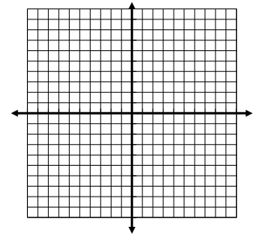

26. For a driver aged x years, a study found that the driver’s reaction time (in milliseconds) to a visual stimulus such as a traffic light can be modeled by: $v=.005x^{2}-0.23x+22$ for drivers from ages 16 to 70. At what age does a driver’s reaction time tend to be greater than 25 milliseconds? (v represents reaction time, x represents age).

27. When a baseball is hit by a batter, the height of the ball, H, at time t, (t  0) , is determined by the equation $H=-16t^{2}+160t+32$. For which interval of time is the height of the ball within 288 feet?