Foundations of Math 2
Fall 2017

Unit 2 Bundle
Transformational Graphing and Quadratic Functions

Contents
Transformations of Functions – Day 1 3
Transformations with Functions – Day 1 HW 10
Transformations with Functions – Day 2 12
Transformations with Functions – Day 2 HW 17
Transformations with Functions – Day 3 18
Transformations with Functions – Day 3 HW 23
Transformations of Quadratic Functions – Day 4 - 6 24
Transformations of Quadratic Functions – Day 4 HW 26
Characteristics of Quadratics - Day 7
Completing the Square - Day 8 - 9
Polynomial Operations - Day 10 - 11
Factoring - Day 12 - 14

Transformations of Functions – Day 1
To the right is a graph of a function F(x). We can use F(x) functions to explore transformations in the coordinate plane.
F(x)
- Let’s review briefly.

- a. Explain what a function is in your own words.

- Using the graph, how do we know that F(x) is a function?

- a. Explain what we mean by the term domain.

b. Using the graph, what is the domain of F(x)?

- a. Explain what we mean by the term range.

b. Using the graph, what is the range of F(x)?

- Let’s explore the points on F(x).
- How many points lie on F(x)? Can you list them all?

- What are the key points that would help us graph F(x)?

We are going to call these key points “characteristic” points. It is important when graphing a function that you are able to identify these characteristic points.

- Use the graph above to evaluate the following.

F(1) = _____ F( –1) = _____ F(_____) = –2 F(5) = ______

- Remember that F(x) is another name for the y-values.
Therefore the equation of F(x) is y = F(x).

X | F(x)
–1
1
2
4

- Why did we choose those x-values to put in the table?

Now let’s try graphing G(x): y = F(x) + 4. Complete the table below for this new function and then graph G(x) on the coordinate plane above.

y = F(x) + 4

X | Y
–1
1
2
4

- What type of transformation maps F(x), to G(x), F(x) + 4? (Be specific.)

- How did this transformation affect the x-values? (Hint: Compare the characteristic points of F(x) and G(x))

- How did this transformation affect the y-values? (Hint: Compare the characteristic points of F(x) and G(x))

- In y = F(x) + 4, how did the “+4” affect the graph of F(x)? Did it affect the domain or the range?

- Suppose G(x)’s equation is: y = F(x) – 3. Complete the table below for this new function and then graph G(x) on the coordinate plane above.

y = F(x) – 3

X | Y
–1
1
2
4

- What type of transformation maps F(x), to G(x), F(x) – 3? Be specific.

- How did this transformation affect the x-values? (Hint: Compare the characteristic points of F(x) and G(x))

- How did this transformation affect the y-values? (Hint: Compare the characteristic points of F(x) and G(x))

- In y = F(x) – 3, how did the “– 3” affect the graph of F(x)? Did it affect the domain or the range?

- Checkpoint: Using the understanding you have gained so far, describe the affect to F(x) for the following functions.

Equation | Effect to F(x)’s graph
Example: y=F(x) + 18 | Translate up 18 units
- y = F(x) – 100
- y = F(x) + 73
- y = F(x) + 32
- y = F(x) – 521

- Suppose G(x)’s equation is: y = F(x + 4).

- Complete the table.

X | x + 4 | y
–5 | –1 | 1
 | 1 | –1
 | 2 | –1
 | 4 | –2

(Hint: Since, x + 4 = –1, subtract 4 from both sides of the equation, and x = –5. Use a similar method to find the missing x values.)

- On the coordinate plane above, graph the 4 ordered pairs (x, y). The first point is (–5, 1).

- What type of transformation maps F(x), to G(x), F(x + 4)? (Be specific.)

- How did this transformation affect the x-values? (Hint: Compare the characteristic points of F(x) and G(x))

- How did this transformation affect the y-values? (Hint: Compare the characteristic points of F(x) and G(x))

- In y = F(x + 4), how did the “+4” affect the graph of F(x)? Did it affect the domain or the range?

- Suppose G(x)’s equation is: y = F(x – 3). Complete the table below for this new function and then graph G(x) on the coordinate plane above.

- Complete the table.

y = F(x – 3)

x | x – 3 | y
 | –1
 | 1
 | 2
 | 4

- On the coordinate plane above, graph the 4 ordered pairs (x, y). [Hint: The 1st point should be (2, 1).]

- What type of transformation maps F(x), to G(x), F(x – 3)? (Be specific.)

- How did this transformation affect the x-values? (Hint: Compare the characteristic points of F(x) and G(x))

- How did this transformation affect the y-values? (Hint: Compare the characteristic points of F(x) and G(x))

- In y = F(x – 3), how did the “ –3” affect the graph of F(x)? Did it affect the domain or the range?

- Checkpoint: Using the understanding you have gained so far, describe the effect to F(x) for the following functions.

Equation | Effect to F(x)’s graph
Example: y=F(x + 18) | Translate left 18 units
- y = F(x – 10)
- y = F(x) + 7
- y = F(x + 48)
- y = F(x) – 22
- y = F(x + 30) + 18

- Checkpoint: Using the understanding you have gained so far, write the equation that would have the following effect on F(x)’s graph.

Equation | Effect to F(x)’s graph
Example: y=F(x + 8) | Translate left 8 units
- ______________________________________ | Translate up 29 units
- ______________________________________ | Translate right 7
- ______________________________________ | Translate left 45
- ______________________________________ | Translate left 5 and up 14
- ______________________________________ | Translate down 2 and right 6

- Now let’s look at a new function.
Its notation is H(x).
Use H(x) to demonstrate what you have learned
so far about the transformations of functions.

- What are H(x)’s characteristic points?

__________________________________________

- Describe the effect on H(x)’s graph for each
of the following.
- H(x – 2) _______________________________________________
- H(x) + 7 _______________________________________________
- H(x+2) – 3 _______________________________________________

- Use your answers to questions 1 and 2 to help you sketch each graph without using a table.

- y = H(x – 2) b. y = H(x) + 7

c. y = H(x+2) – 3

Transformations with Functions – Day 1 HW
On each grid, R(x) is graphed. Graph the given function.

- Graph: y = R(x) – 6.

- Graph: y = R(x + 6)

- Graph: y = R(x + 2) + 5

- Graph: y = G(x – 4) – 5

- Using the understanding you have gained so far, describe the effect to F(x) for the following functions.
Equation | Effect to F(x) graph
- y = F(x) + 82
- y = F(x – 13)
- y = F(x + 9)
- y = F(x) – 55
- y = F(x – 25) + 11

- Using the understanding you have gained so far, write the equation that would have the following effect on F(x)’s graph.

Equation | Effect to F(x)’s graph
- _________________________________________ | Translate left 51 units
- _________________________________________ | Translate down 76
- _________________________________________ | Translate right 31
- _________________________________________ | Translate right 8 and down 54
- _________________________________________ | Translate down 12 and left 100
- Determine the domain and range of each parent function.
- H(x) 2. R(x)

Domain: ____________________ Domain: ____________________
Range: ____________________ Range: ____________________
- Consider a new function, P(x).
P(x)’s Domain is $\left\{x\right|-2 ≤x ≤2\}$. Its range is $\left\{y\right|-3 ≤y ≤1\}$.

Use your understanding of transformations of functions to determine the domain and range of each of the following functions. (Hint: You may want to write the effect to P(x) first.)

- P(x) + 5 2. P(x + 5)

Domain: ___________________________ Domain: ___________________________
Range: ___________________________ Range: ___________________________

Transformations with Functions – Day 2
Today we will revisit F(x), our “parent” function, and investigate transformations other than translations.
Recall that the equation for F(x) is y = F(x).
F(x)
Complete the chart with F(x)’s characteristic points.
x | F(x)

- Let’s suppose that G(x) is y = – F(x)
- Complete the table.

y = – F(x)

x | F(x) | y
–1 | 1 | –1
1
2
4

- On the coordinate plane above, graph the 4 ordered pairs (x, y). [Hint: The 1st point should be (–1, –1).]

- What type of transformation maps F(x) to G(x), –F(x)? (Be specific.)

- How did this transformation affect the x-values? (Hint: Compare the characteristic points of F(x) and G(x))

- How did this transformation affect the y-values? (Hint: Compare the characteristic points of F(x) and G(x))

- In y = – F(x), how did the negative coefficient of “F(x)” affect the graph of F(x)? How does this relate to our study of transformations earlier this semester?

- Now let’s suppose that G(x) is y = F(–x)
F(x)
- Complete the table.

y = F(–x)

x | –x | y
 | –1
 | 1
 | 2
 | 4

- On the coordinate plane above, graph the 4 ordered pairs (x, y). [Hint: The 1st point should be (1, 1).]

- What type of transformation maps F(x) to G(x), F(–x)? (Be specific.)

- How did this transformation affect the x-values? (Hint: Compare the characteristic points of F(x) and G(x))

- How did this transformation affect the y-values? (Hint: Compare the characteristic points of F(x) and G(x))

- In y = F(–x), how did the negative coefficient of “x” affect the graph of F(x)? How does this relate to our study of transformations earlier this semester?

- Checkpoint: H(x) is shown on each grid. Use H(x)’s characteristic points to graph H(x)’s children without making a table.
- y = H(–x) 2. y = – H(x)

- Now let’s return to F(x), whose equation is y = F(x).
F(x)
Complete the chart with F(x)’s characteristic points.
x | F(x)

Let’s suppose that G(x) is y = 4 F(x)
- Complete the table.

y = 4 F(x)

x | F(x) | y
–1
1
2
4

- On the coordinate plane above, graph the 4 ordered pairs (x, y). [Hint: The 1st one should be (–1, 4).]

- How did this transformation affect the x-values? (Hint: Compare the characteristic points of F(x) and G(x))

- How did this transformation affect the y-values? (Hint: Compare the characteristic points of F(x) and G(x))

- In y = 4 F(x), the coefficient of “F(x)” is 4. How did that affect the graph of F(x)? Is this one of the transformations we studied? If so, which one? If not, explain.

- Now let’s suppose that G(x) is y = ½ F(x).
F(x)
- Complete the table.

y = ½ F(x)

x | F(x) | y
–1
1
2
4

- On the coordinate plane above, graph the 4 ordered pairs (x, y). [Hint: The 1st one should be (–1, ½).]

- How did this transformation affect the x-values? (Hint: Compare the characteristic points of F(x) and G(x))

- How did this transformation affect the y-values? (Hint: Compare the characteristic points of F(x) and G(x))

- In y = ½ F(x), the coefficient of “F(x)” is ½. How did that affect the graph of F(x)? How is this different from the graph of y = 4 F(x) on the previous page?

- Checkpoint:
- Complete each chart below. Each chart starts with the characteristic points of F(x).

x | F(x) | 3 F(x)
–1 | 1
1 | –1
2 | –1
4 | –2
x | F(x) | ¼ F(x)
–1 | 1
1 | –1
2 | –1
4 | –2

- Compare the 2nd and 3rd columns of each chart above. The 2nd column is the y-value for F(x). Can you make a conjecture about how a coefficient changes the parent graph?

- Now let’s suppose that G(x) is y = –3 F(x).
F(x)

- Complete the table.

y = –3 F(x)

x | F(x) | y
–1
1
2
4

- On the coordinate plane above, graph the 4 ordered pairs (x, y). [Hint: The 1st one should be (–1, –3).]

- Reread the conjecture you made in #7 on the previous page. Does it hold true or do you need to refine it?
If it does need some work, restate it more correctly here.

- Checkpoint: Let’s revisit H(x).
- Describe the effect on H(x)’s graph for each of the following.
Example: –5H(x) Each point is reflected in the x-axis and is 5 times as far from the x-axis.
- 3H(x) ____________________________________________________________________________
- –2H(x) ____________________________________________________________________________
- $\frac{1}{2}$H(x) ____________________________________________________________________________

- Use your answers to questions 1 and 2 to help you sketch each graph without using a table.

- y = 3H(x) b. y = –2H(x) c. y = $\frac{1}{2}$H(x)

Transformations with Functions – Day 2 HW
This is the function B(x).
- List its characteristic points.

- Are these the only points on the graph of B(x)? Explain.

- What is the domain of B(x)?

- What is the range of B(x)?

For each of the following, list the effect on the graph of B(x) and then graph the new function.

- y = B(– x) 6. y = – B(x) 7. y = $\frac{1}{3}$ B(x)

8. y = 3 B(x) 9. y = B(x – 3) 10. y = B(x + 2) – 1

Transformations with Functions – Day 3
.
The graph of D(x), is shown.

List the characteristic points of D(x).

__________________________________________________

What is different about D(x) from the functions we have
used so far?

Since D(x) is our original function, we will refer to him as
the parent function. Using our knowledge of transformational
functions, let’s practice finding children of this parent.

Note: In transformational graphing where there are multiple steps, it is important to perform the translations last.

- Example: Let’s explore the steps to graph D(x) Jr, 2D(x + 3) + 5, without using tables.

- The transformations represented in this new function are listed below in the order they will be performed. (See note above.)
- Vertical stretch by 2 (Each point moves twice as far from the x-axis.)
- Translate left 3.
- Translate up 5.

- On the graph, put your pencil on the left-most characteristic point, (– 5, –1) .
- Vertical stretch by 2 takes it to (– 5, –2). (Note that the originally, the point was 1 unit away from the x-axis. Now, the new point is 2 units away from the x-axis.)
- Starting with your pencil at (– 5, –2), translate this point 3 units to the left. Your pencil should now be on (– 8, –2).
- Starting with your pencil at (– 8, –2), translate this point up 5 units. Your pencil should now be on (– 8, 3).
- Plot the point (– 8, 3). It is recommended that you do this using a different colored pencil.

- Follow the process used in Step 2 above to perform all the transformations on the other 3 characteristic points.

- After completing Step 3, you will have all four characteristic points for E(x) Use these to complete the graph of E(x) Be sure you use a curve in the appropriate place. D(x) is not made of segments only.

- D(x) has another child named C(x), – D(x) – 4
.
Using the process in the previous example as a guide,
graph C(x) (without using tables).

1. List the transformations needed to graph C(x).
(Remember, to be careful with order.)

- _____________________________________________

- _____________________________________________

2. Apply the transformations listed above to each of the four characteristic points.

3. Complete the graph of C(x) using your new characteristic points from #2.

- D(x) has another child named A(x), 3 D(– x)
.
Using the process in the previous example as a guide,
graph A(x) (without using tables).

1. List the transformations needed to graph A(x).
(Remember, to be careful with order.)

- _____________________________________________

- _____________________________________________

2. Apply the transformations listed above to each of the four characteristic points.

3. Complete the graph of A(x) using your new characteristic points from #2.

- Now that we have practiced transformational graphing with D(x) and his children, you and your partner should use the process learned from the previous three problems to complete the following.

- Given K(x), graph: y = 3K(x) + 5

- Given J(x), graph: y = – J(x – 3) – 6

- Given H(x), graph y = – 3H(x)

- Given B(x), graph: y = B(–x) + 8

- Given M(x), graph: y = $-\frac{1}{3}$ M(x)

- Finally, let’s examine a reflection of H(x) in the line y = x.

- Graph this line (y = x) on the grid.

- Using H(x)’s characteristic points and the MIRA,
graph H(x)’s reflection.

- Complete the charts below with the characteristic points:
y = H(x) H(x)’s reflection in y = x:

x |  | y
x | y

- Compare the points in the two charts. Describe what happens when we reflect in the line y = x.
(This should match what we learned in our earlier study of reflections in the line y = x.)

- A reflection in the line y = x, shows a graph’s inverse. We will study this in more depth in a future unit. Look at the graph of H(x)’s inverse. Is the inverse a function? Explain how you know.

Transformations with Functions – Day 3 HW
- List the transformations needed to graph the following. Remember that translations are done last.

- y = $2F\left(x\right)+2$ ____________________________________________________________________
____________________________________________________________________
- y = $\frac{1}{3}F(x-6)$ ____________________________________________________________________ ____________________________________________________________________
- y = $-F\left(x\right)-12$ ____________________________________________________________________
____________________________________________________________________
- y = 3F(-x) ____________________________________________________________________ ____________________________________________________________________
- y = $-$5F(x) ____________________________________________________________________ ____________________________________________________________________
- Looking back at the examples of parent functions we have worked with, create your own original parent function on the graph. Make sure that you have graphed a function.

- How can you tell your graph is a function?

- Explain the name you picked.

- Write an equation for your function that will have the
following effects.

- Stretch vertically by 2 and translate left 4.

______________________________________

- Reflect in the x-axis and compress vertically by $\frac{1}{2}$
_______________________________________
- Translate up 6 and right 4
________________________________________
- Graph each of the children from part c above using a separate graph for each. You will need to use your own graph paper.
Day 4-6: Graphing Quadratics in Vertex Form
Quadratic Functions

The parent function for a quadratic is ____________________

The _____________ is NOT a transformation

Example 1: Identify the transformations $y={\left(x-3\right)}^{2}+5$

You Try 1: Identify the transformations
$$y={3\left(x+1\right)}^{2}-3$$

You Try 2: Identify the transformations
$y={-2\left(x\right)}^{2}+4$

x | y
For a quadratic function the critical points are:

Domain:____________________

Range:______________________

Example 2: Find and graph the new critical points for the equation $y={\left(x-3\right)}^{2}+5$
x | y

- Determine the transformations that affect the x-values

- Determine the transformations that affect the y-values

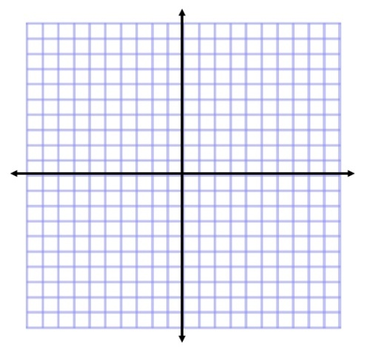
- Graph the new points

New Domain:_______________

New Range:________________

Example 3: Find and graph the new critical points for the equation $y={3\left(x+1\right)}^{2}-3$

x | y

- Determine the transformations that affect the x-values

- Determine the transformations that affect the y-values

- Graph the new points

New Domain:_______________

New Range:________________

You Try 3: Find and graph the new critical points for the equation $y={-2\left(x\right)}^{2}+4$
x | y

- Determine the transformations that affect the x-values

- Determine the transformations that affect the y-values

- Graph the new points

New Domain:_______________

New Range:________________

Transformations of Quadratic Functions – Day 4 HW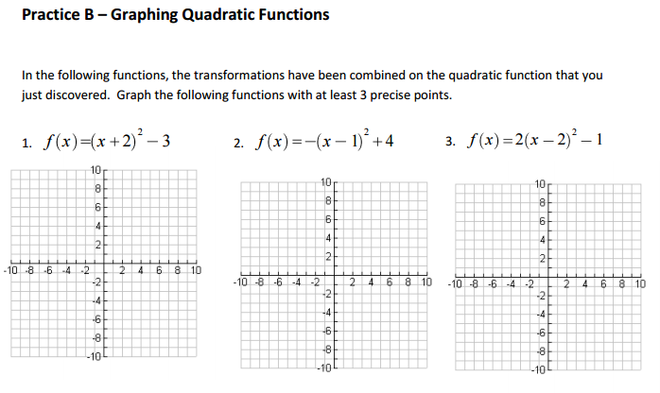

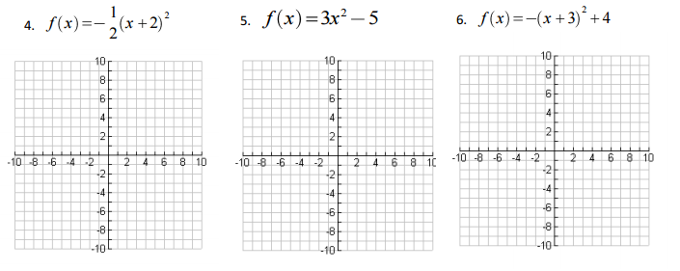

Day 7: Characteristics of Quadratics
Introduction:
- A __________________ written in _______________ looks like:
- The graph of a quadratic function is U-shaped and called a ________________.
- The highest or lowest point of the graph occurs at the ____________________.
- Parabolas have a line of symmetry (splits the graph in half) called the _____________________.

Parabolas Have These Characteristics:
- If a > 0 then the parabola opens ____, but if a < 0 then the parabola opens _____.
- The x-coordinate of the vertex is _________.
- The maximum or minimum of the graph is at the _________.
- The axis of symmetry is the vertical line ___________.
- The y-intercept is __________.

Find the key features of the quadratic function represented below.
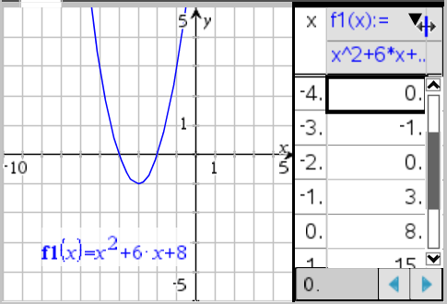

Domain:
Range:
Minimum Point:
Axis of Symmetry:
x-Intercepts:
y-Intercept:
Interval of Increase:
Interval of Decrease:

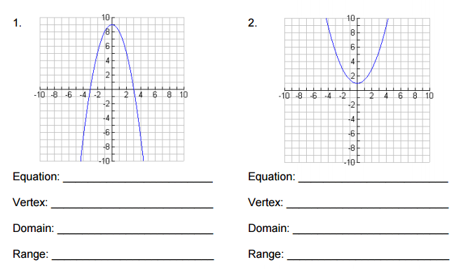

Interval of Increase: ______________
Interval of Decrease: _____________
Interval of Increase: ______________
Interval of Decrease: _____________

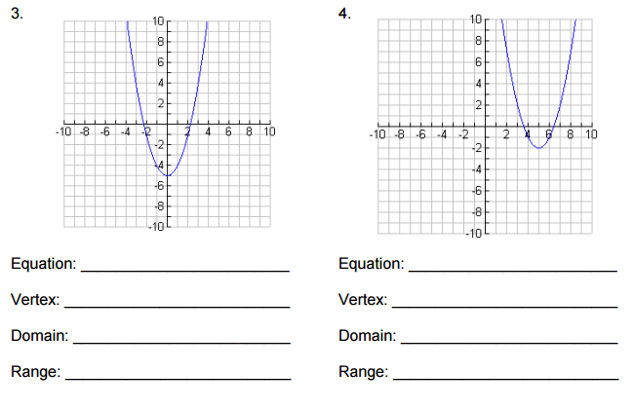

Interval of Increase: ______________
Interval of Decrease: _____________
Interval of Increase: ______________
Interval of Decrease: _____________

Day 8-9: Completing the square

Completing the square is a process for turning a quadratic from ____________________ into ____________________ since it is significantly easier to graph in that form.

Step 1: Rewrite the equation into Standard Form

Step 2: Group the two variable terms together

Step 3: Factor out the leading coefficient from the x² term.
-This may mean that you have a decimal for the x term.

Step 4: Find the value of $\frac{b}{2}$ and ${\left(\frac{b}{2}\right)}^{2}$.

Step 5: Add the ${\left(\frac{b}{2}\right)}^{2}$ to the variable portion while also creating an equal and opposite term outside of the variable portion.

Step 6: Factor and Combine Like terms

Example 1: Complete the square for the equation y = x² – 10x + 22

Example 2: Complete the square for the equation y = x² – 8x + 13

You Try 1: Complete the square for the equation y = x² – 4x + 1

Example 3: Complete the square for the equation y = 2x² + 24x + 25

Example 4: Complete the square for the equation y = 2x² – 28x + 99

You Try 2: Complete the square for the equation y = 5x² + 10x + 7

Use the information provided to write the vertex form equation of each parabola.

1) y = x² + 16x + 71
2) y = x² − 2x − 5

3) y = x² − 14x − 59
4) y = x² − 12x + 46

5) y = 4x² + 16x – 21
6) y = 2x² + 20x + 170

7) y = 3x² − 18x + 5
8) y = 5x² + 50x + 33

©C O2B071W2v

Complete the square and then graph each of the following quadratic equations
1.. Graph the quadratic y = x² – 12x + 33

2. Graph

3.. Graph the quadratic y = -2x² – 8x – 3

Day 10-11: Polynomial Operations
For each pair of polynomials, find the sum [f(x)+g(x)] and the difference [f(x)-g(x)].
- f(x) = 3p² - 2p + 3 and g(x) = p² - 7p + 7

Sum:________________________ Difference: _________________________

- f(x) = 7x² - 8 and g(x) = 3x² + 1

Sum:________________________ Difference: _________________________

Sum:________________________ Difference: _________________________

Sum:________________________ Difference: _________________________

Sum:________________________ Difference: _________________________

Sum:________________________ Difference: _________________________

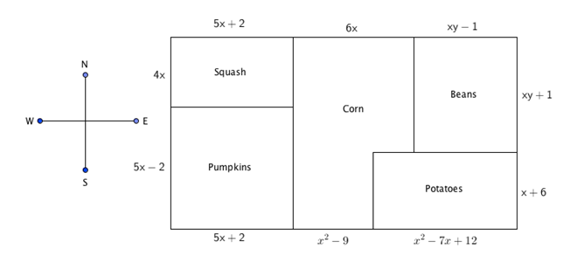
Farmer Bob is planting a garden this spring. He wants to plant squash, pumpkins, corn, beans, and potatoes. His plan for the field layout in feet is shown in the figure below. Use the figure and your knowledge of polynomials, perimeter, and area to solve the following:

a. Write an expression that represents the length of the south side of the field.

b. Simplify the polynomial expression that represents the south side of the field.

c. Write a polynomial expression that represents the area of the pumpkin field.

d. Simplify the polynomial expression that represents the area of the pumpkin field. State one reason why the perimeter would be useful to Farmer Bob.

e. Write a polynomial expression that represents the area of the potato field.

f. Simplify the polynomial expression that represents the area of the potato field. State one reason why the calculated area would be useful to Farmer Bob.

If the base of a triangle has a length of 8x units, and the height is units, write a simplified algebraic expression for the area of the triangle in terms of x.

A square has a side length of k. If the length of the square is increased by 6 units, and the width of the square is increased by 4 units to create a new, larger rectangle, write a simplified algebraic expression for the area of the new rectangle in terms of k.

- Bob mowed (2x² + 5x – 3) yards on Monday, (4x – 7) yards on Tuesday, and (3x² + 10) yards on Wednesday.
  - How many yards did he mow in the three days?

  - If Bob mowed 14x² + 12x – 3 yards total for the entire week, how many yards did he mow during the rest of the week?

- Molly has (4x + 10) dollars and Ron has (-5x + 20) dollars.
  - How much money do they have altogether?

  - How much more money does Molly have than Ron?

CC Math I Standards: Unit 6
SPECIAL PROBLEMS: Find the area of the shaded region in the simplest form.
(BIG SHAPE) – (LITTLE SHAPE “HOLE”) = SHADED REGION

3) 4) 5)
3t
8 -2t
t
3 - t
3x
3x
5x - 2
4x
11y
6y
6y
11y

Exapnd (a + 3) (a² + 7a + 6)

Expand (y - 5) (4y² – 3y + 2)

Day 12-14: Factoring
- Factoring Polynomials
  - ALWAYS factor out the ______________ ______________ ____________
(____________) FIRST!
  - A polynomial that cannot be factored is ___________________.
  - A polynomial is considered to be completely factored when it is expressed as the product of prime polynomials.

- Factoring out the GCF:

- Factor by Grouping: for polynomials with 4 or more terms

- Factoring Trinomials
  - When the leading coefficient is 1

  - When the leading coefficient is not 1

- Difference of “Two Squares”: Rule:___________________________________________

-List of Perfect Squares __________________________________________________________

Extra Factoring Practice
